

D4: Storyboards

Team One: Education

03/03/15

Informatics 131: Discussion A

Cassie Jeansonne 3914

Sophia Chan 6560

Sean Letzer 3320

Stevanus Iskandar 6911

TABLE OF CONTENTS

TABLE OF CONTENTS 2

PART 1: STORYBOARDS 3

Diagram 1: Solution One Storyboards 3

Storyboard One 3

Storyboard Two 4

Diagram 2: Solution Two Storyboards 5

Storyboard One 5

Storyboard Two 6

Diagram 3: Solution Three Storyboards 7

Storyboard One 7

Storyboard Two 8

PART 2: DESIGN SOLUTION CHOICE 9

PART 1: STORYBOARDS

DIAGRAM 1: Solution One Storyboards

**Storyboard One**

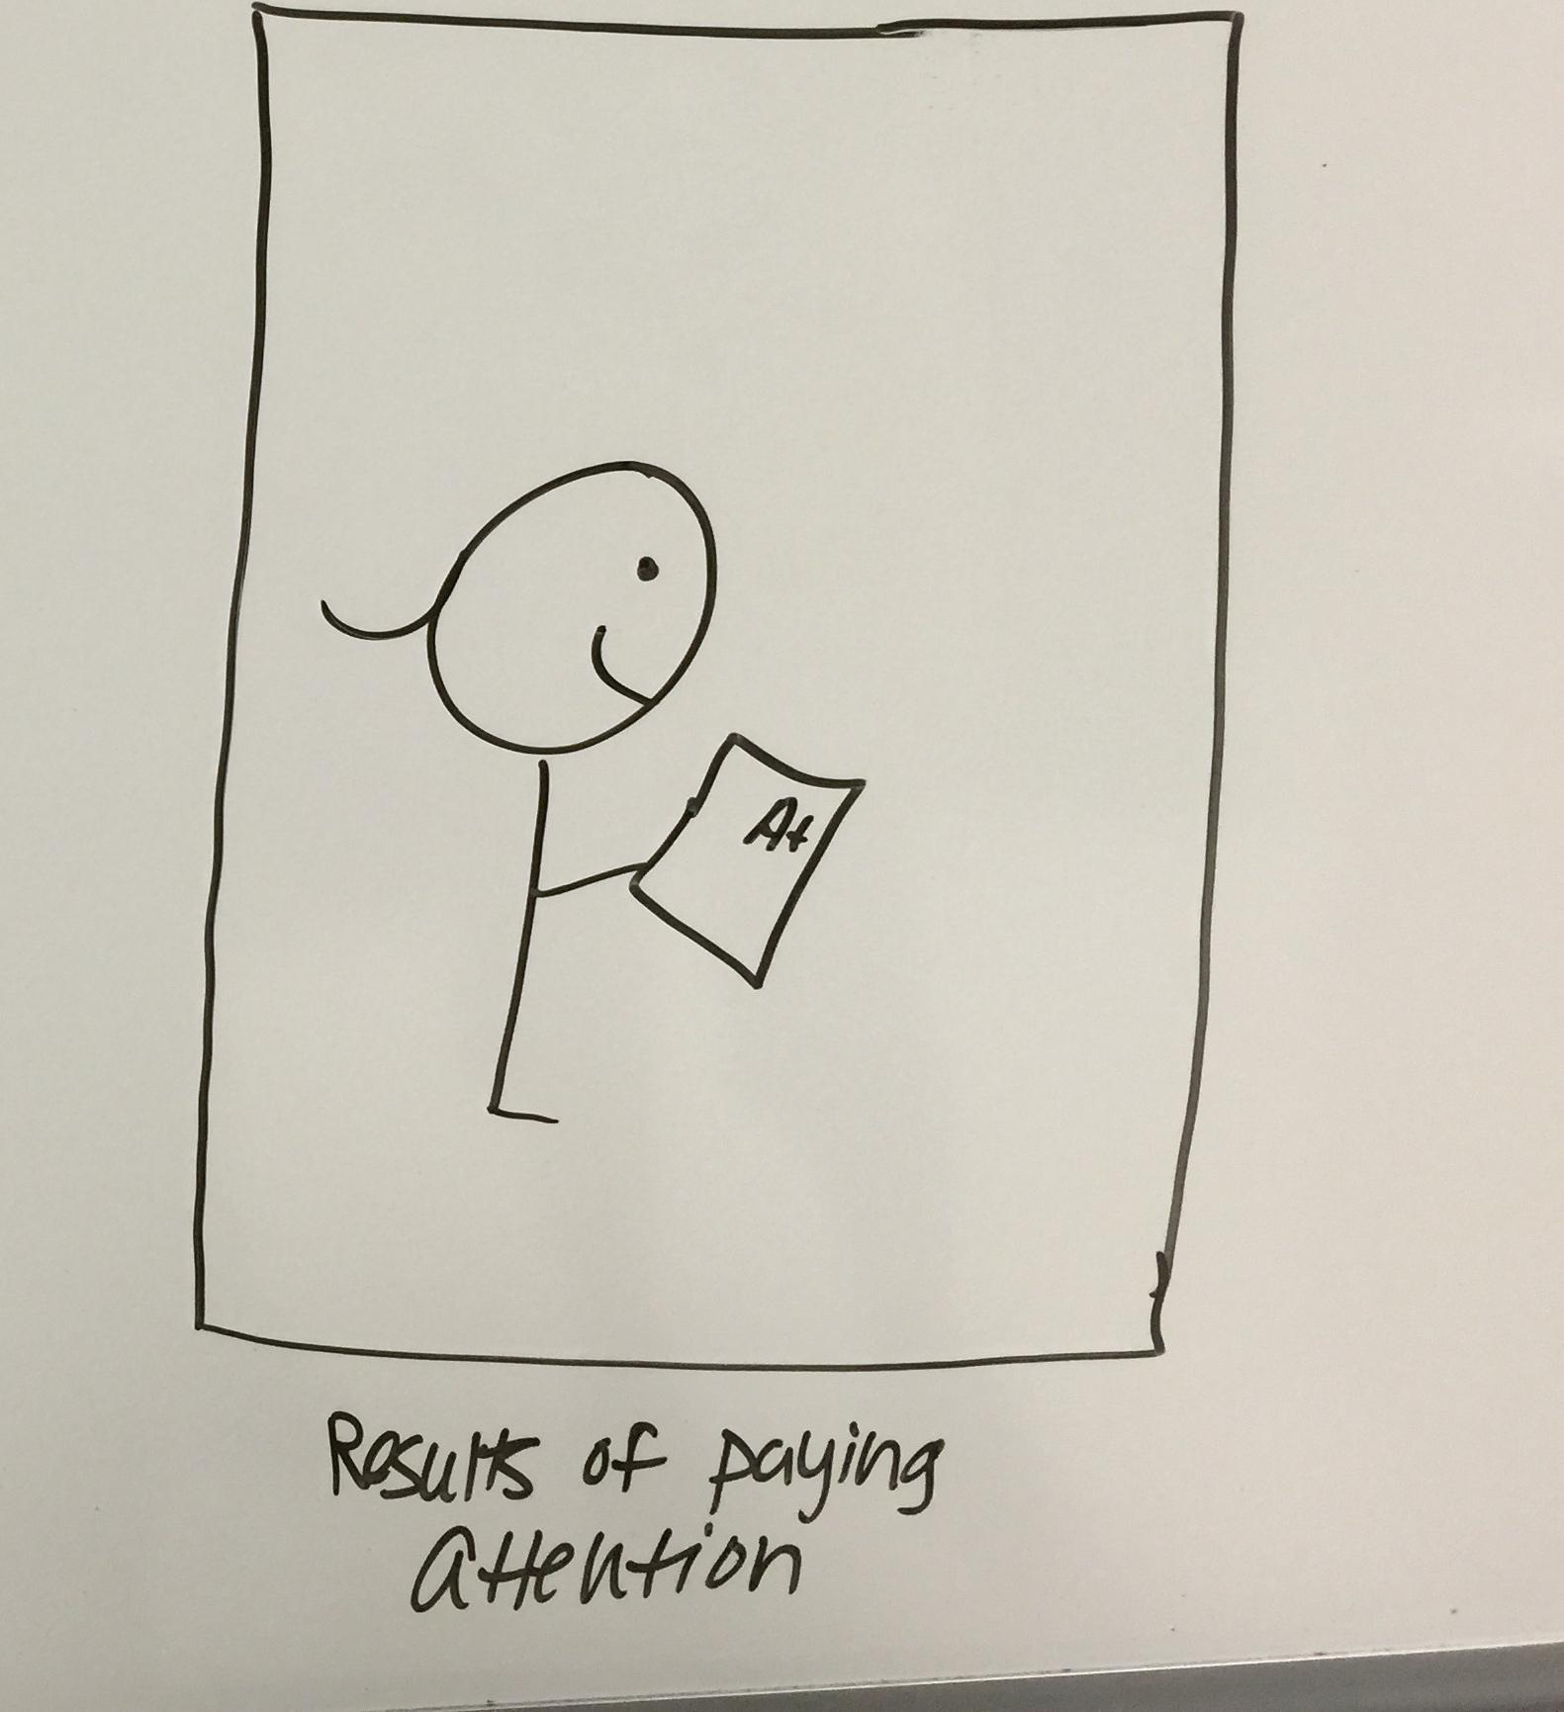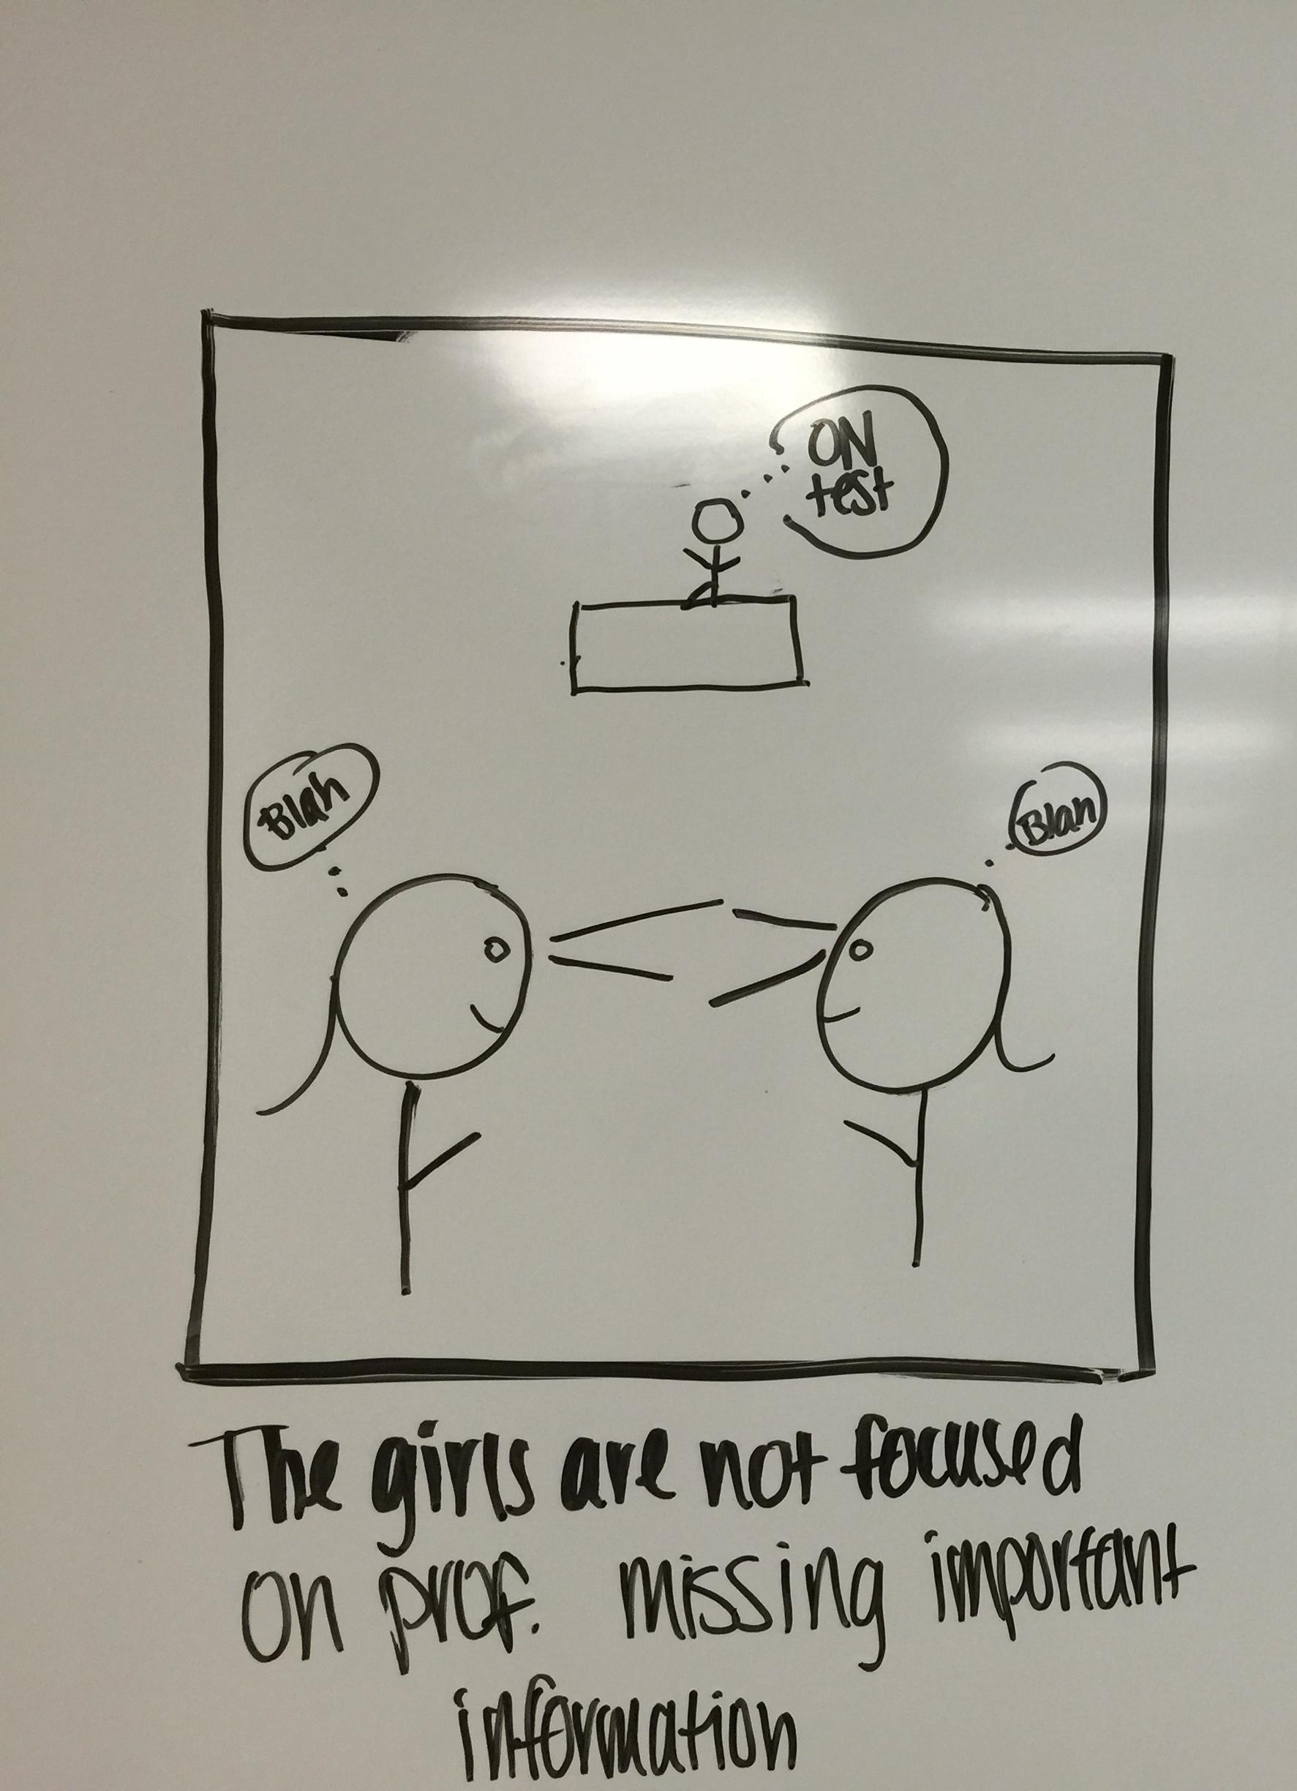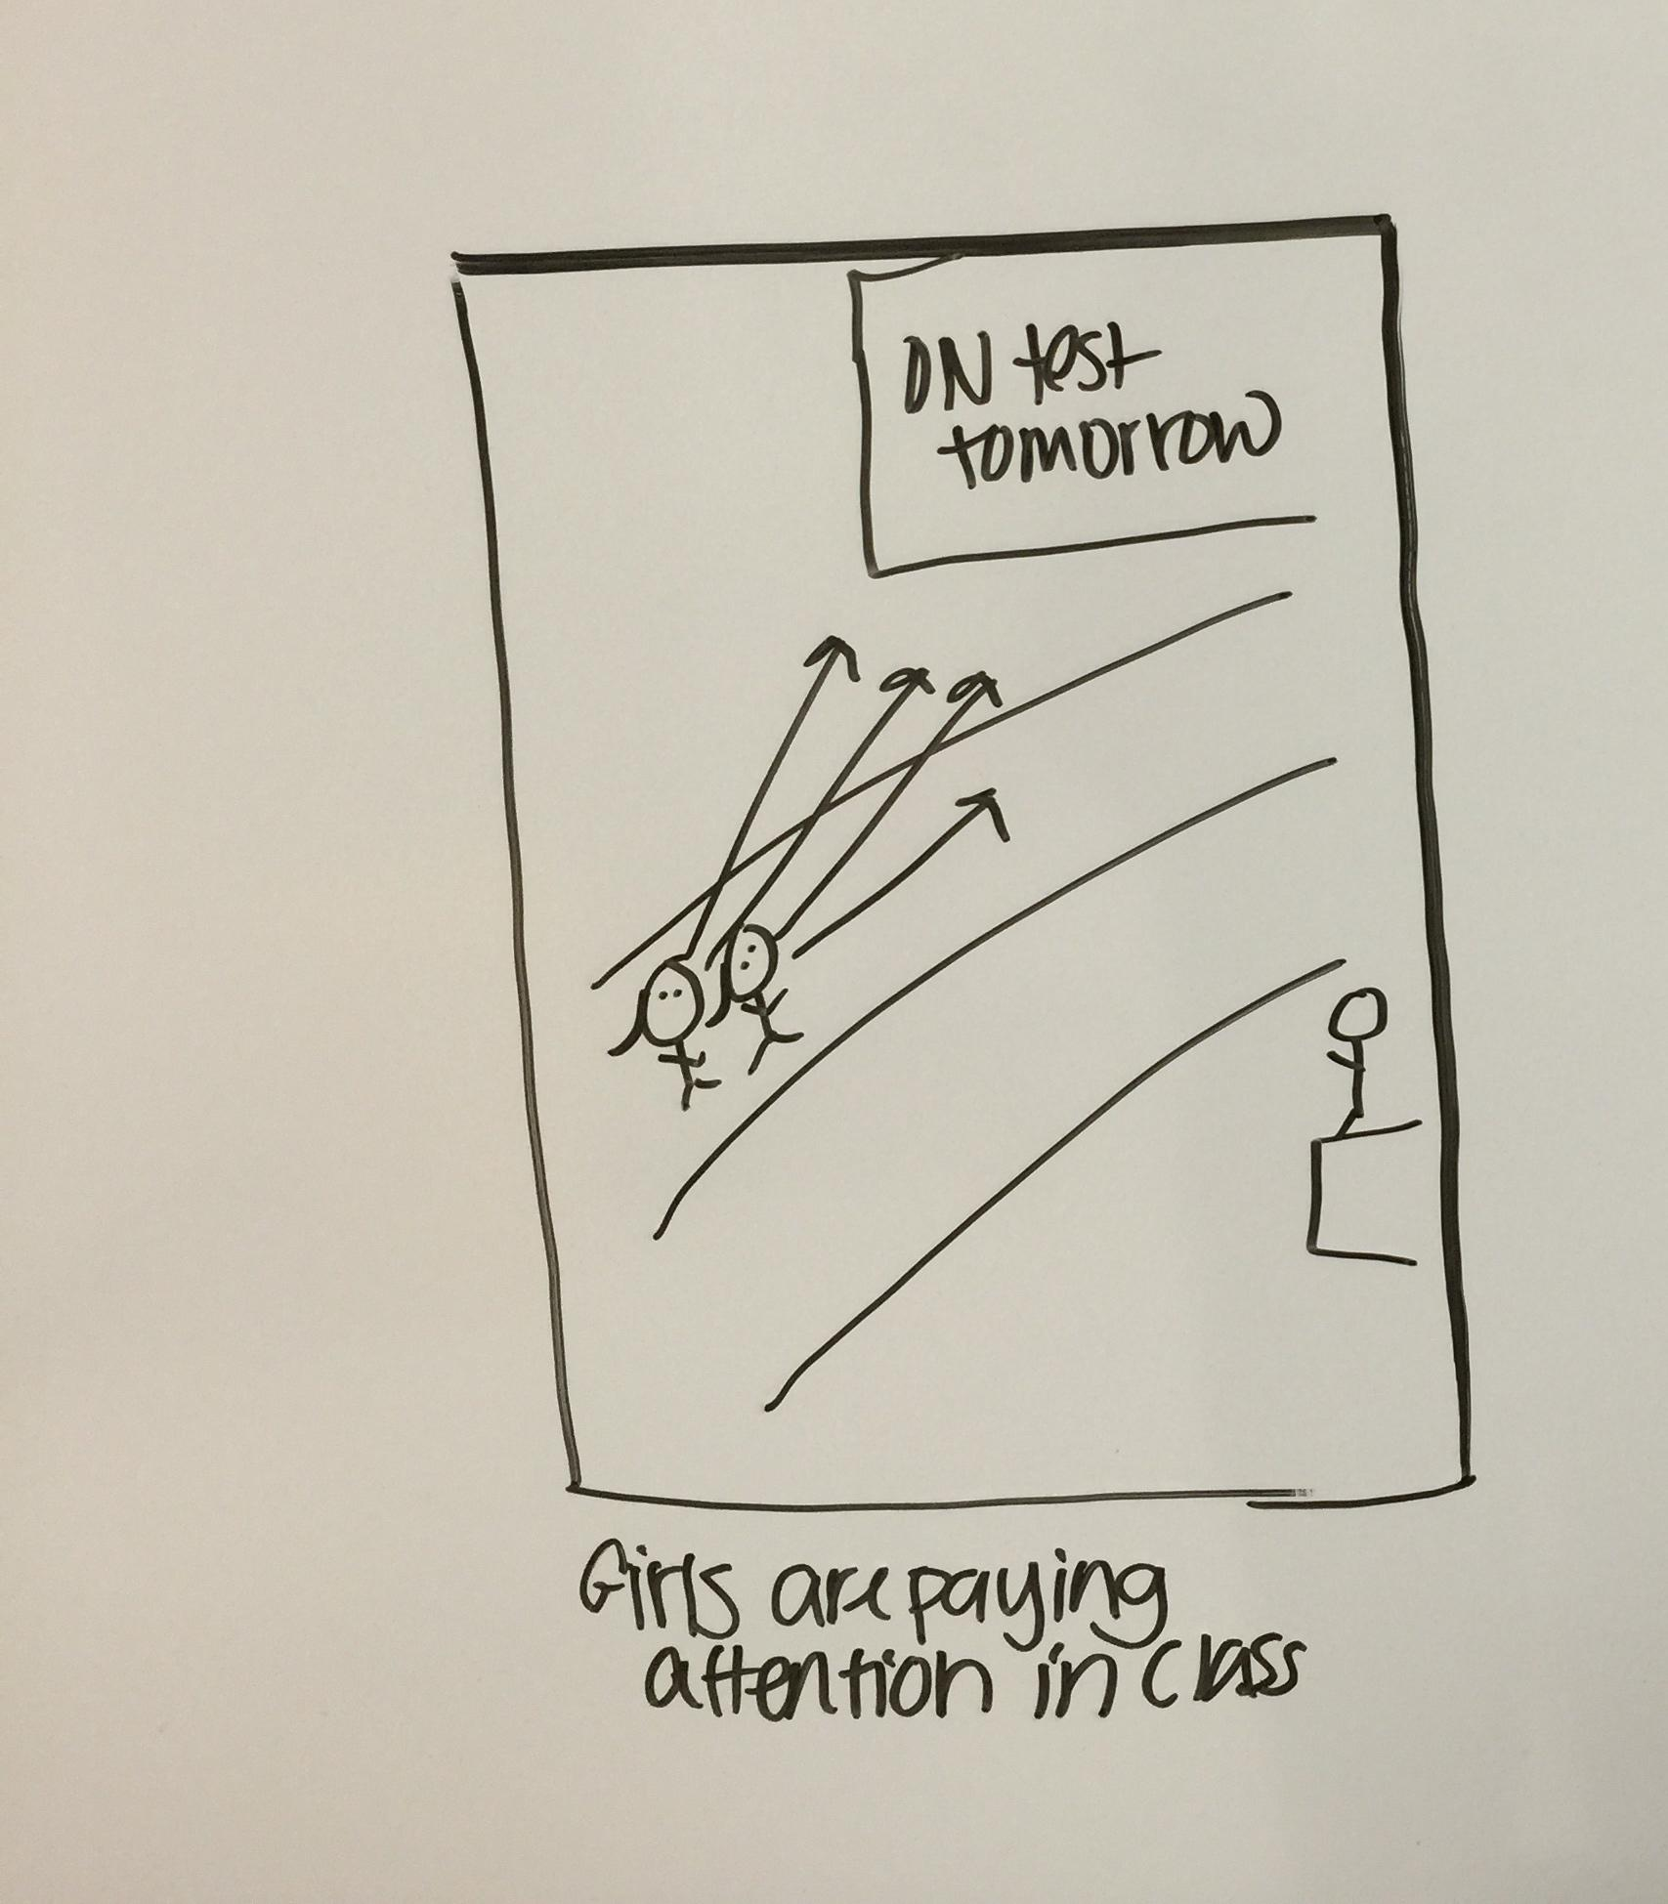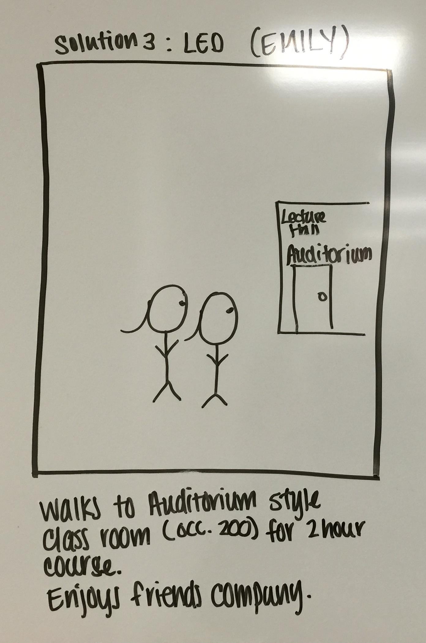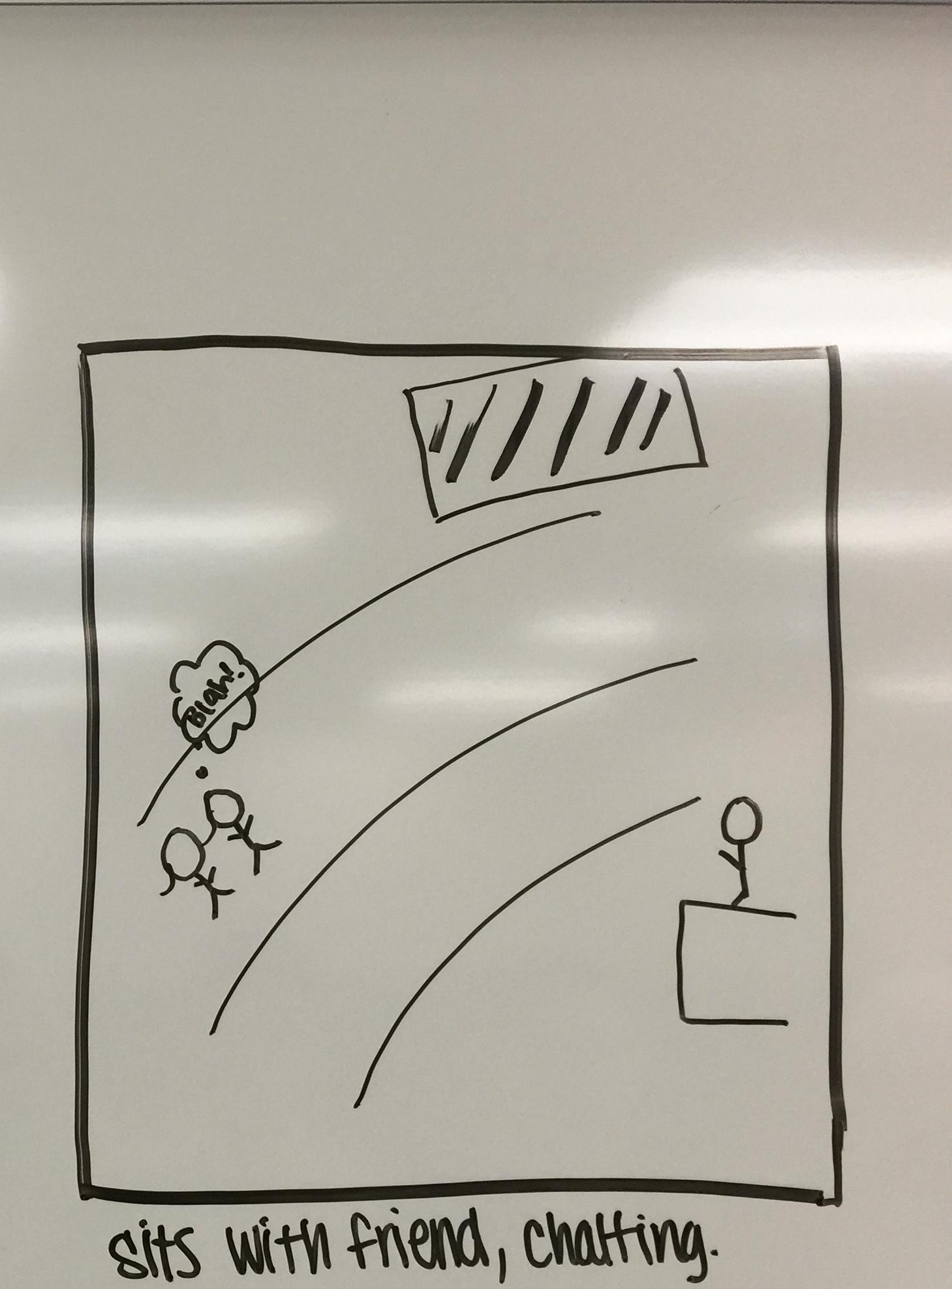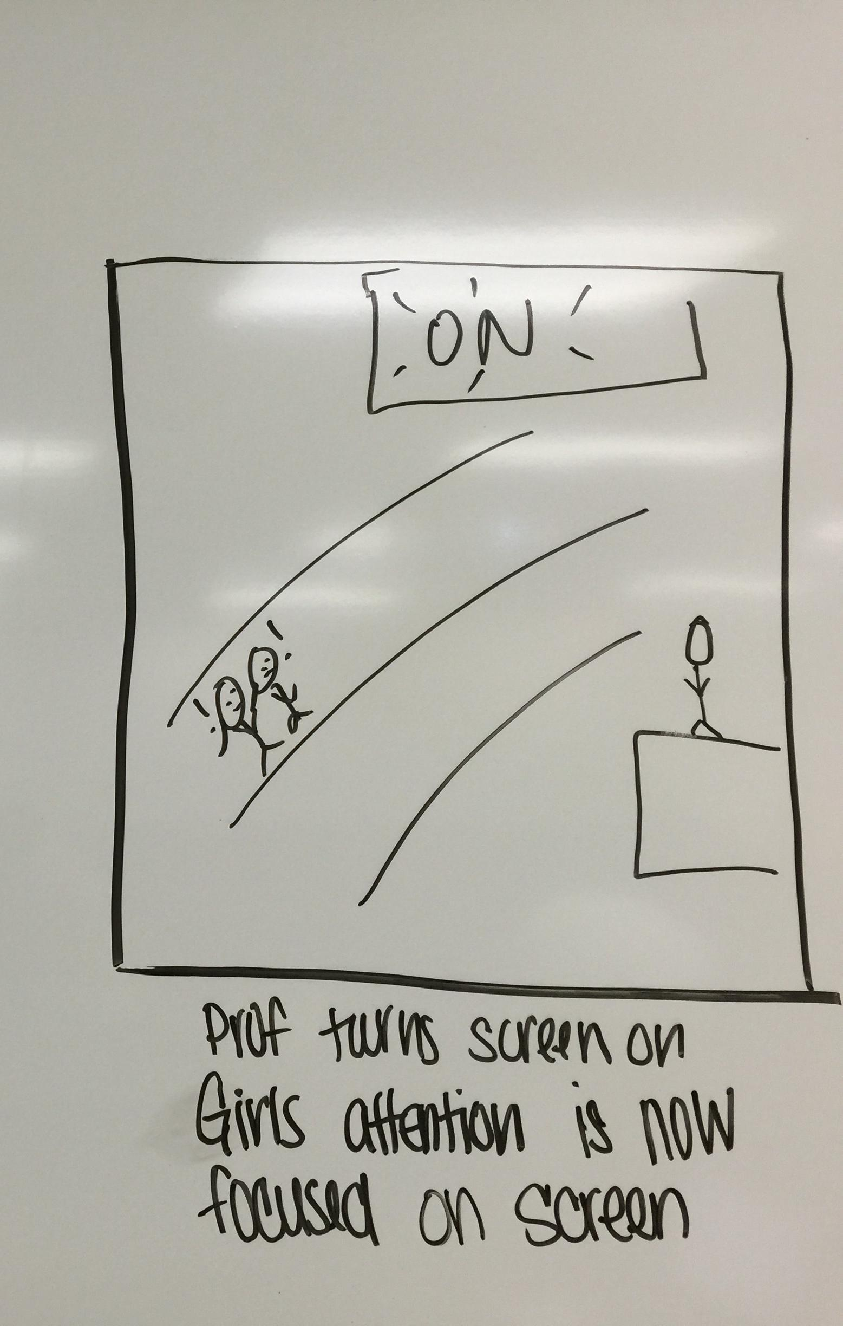

The above storyboard is drawn with the persona, Emily, used as a model for behaviors. To clarify, there are more than one LED screens and they are located in a way similar to a sports stadium or concert hall. They hang from the ceiling along the edges of the auditorium so no matter where a student is seated, an image of the professor is projected in front of them. The screens would be broken up as a split screen, a feed of professor lecturing and his supplementary material such as a power-point. Emily is a social person, she is easily distracted by her friends, social media, and social games so the large LED screens interrupt conversations that normally would keep Emily distracted during class.

**Storyboard Two**

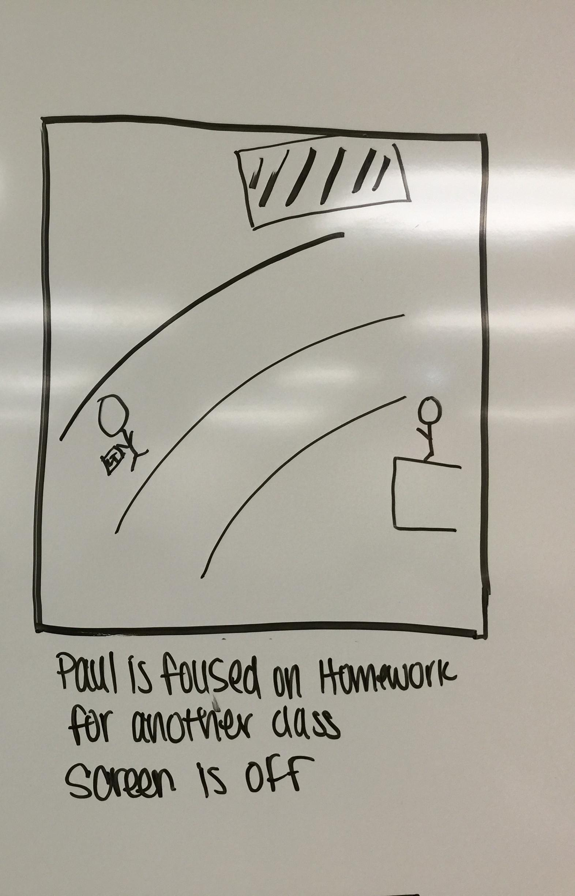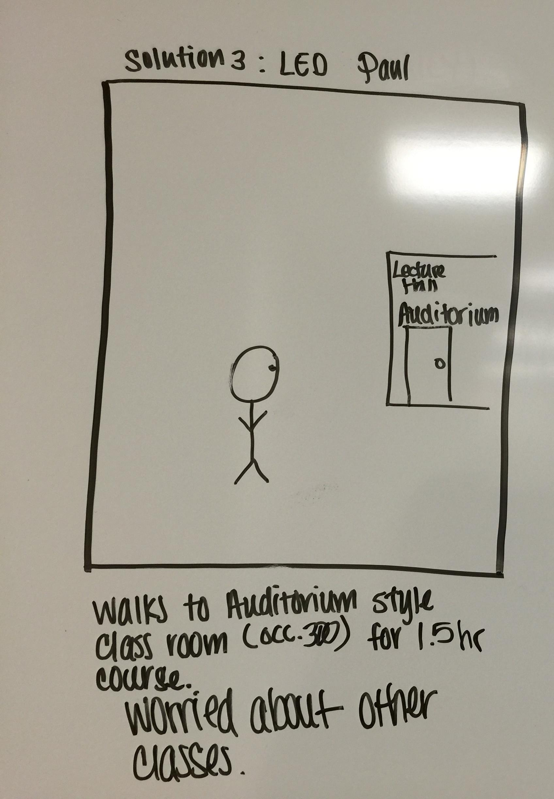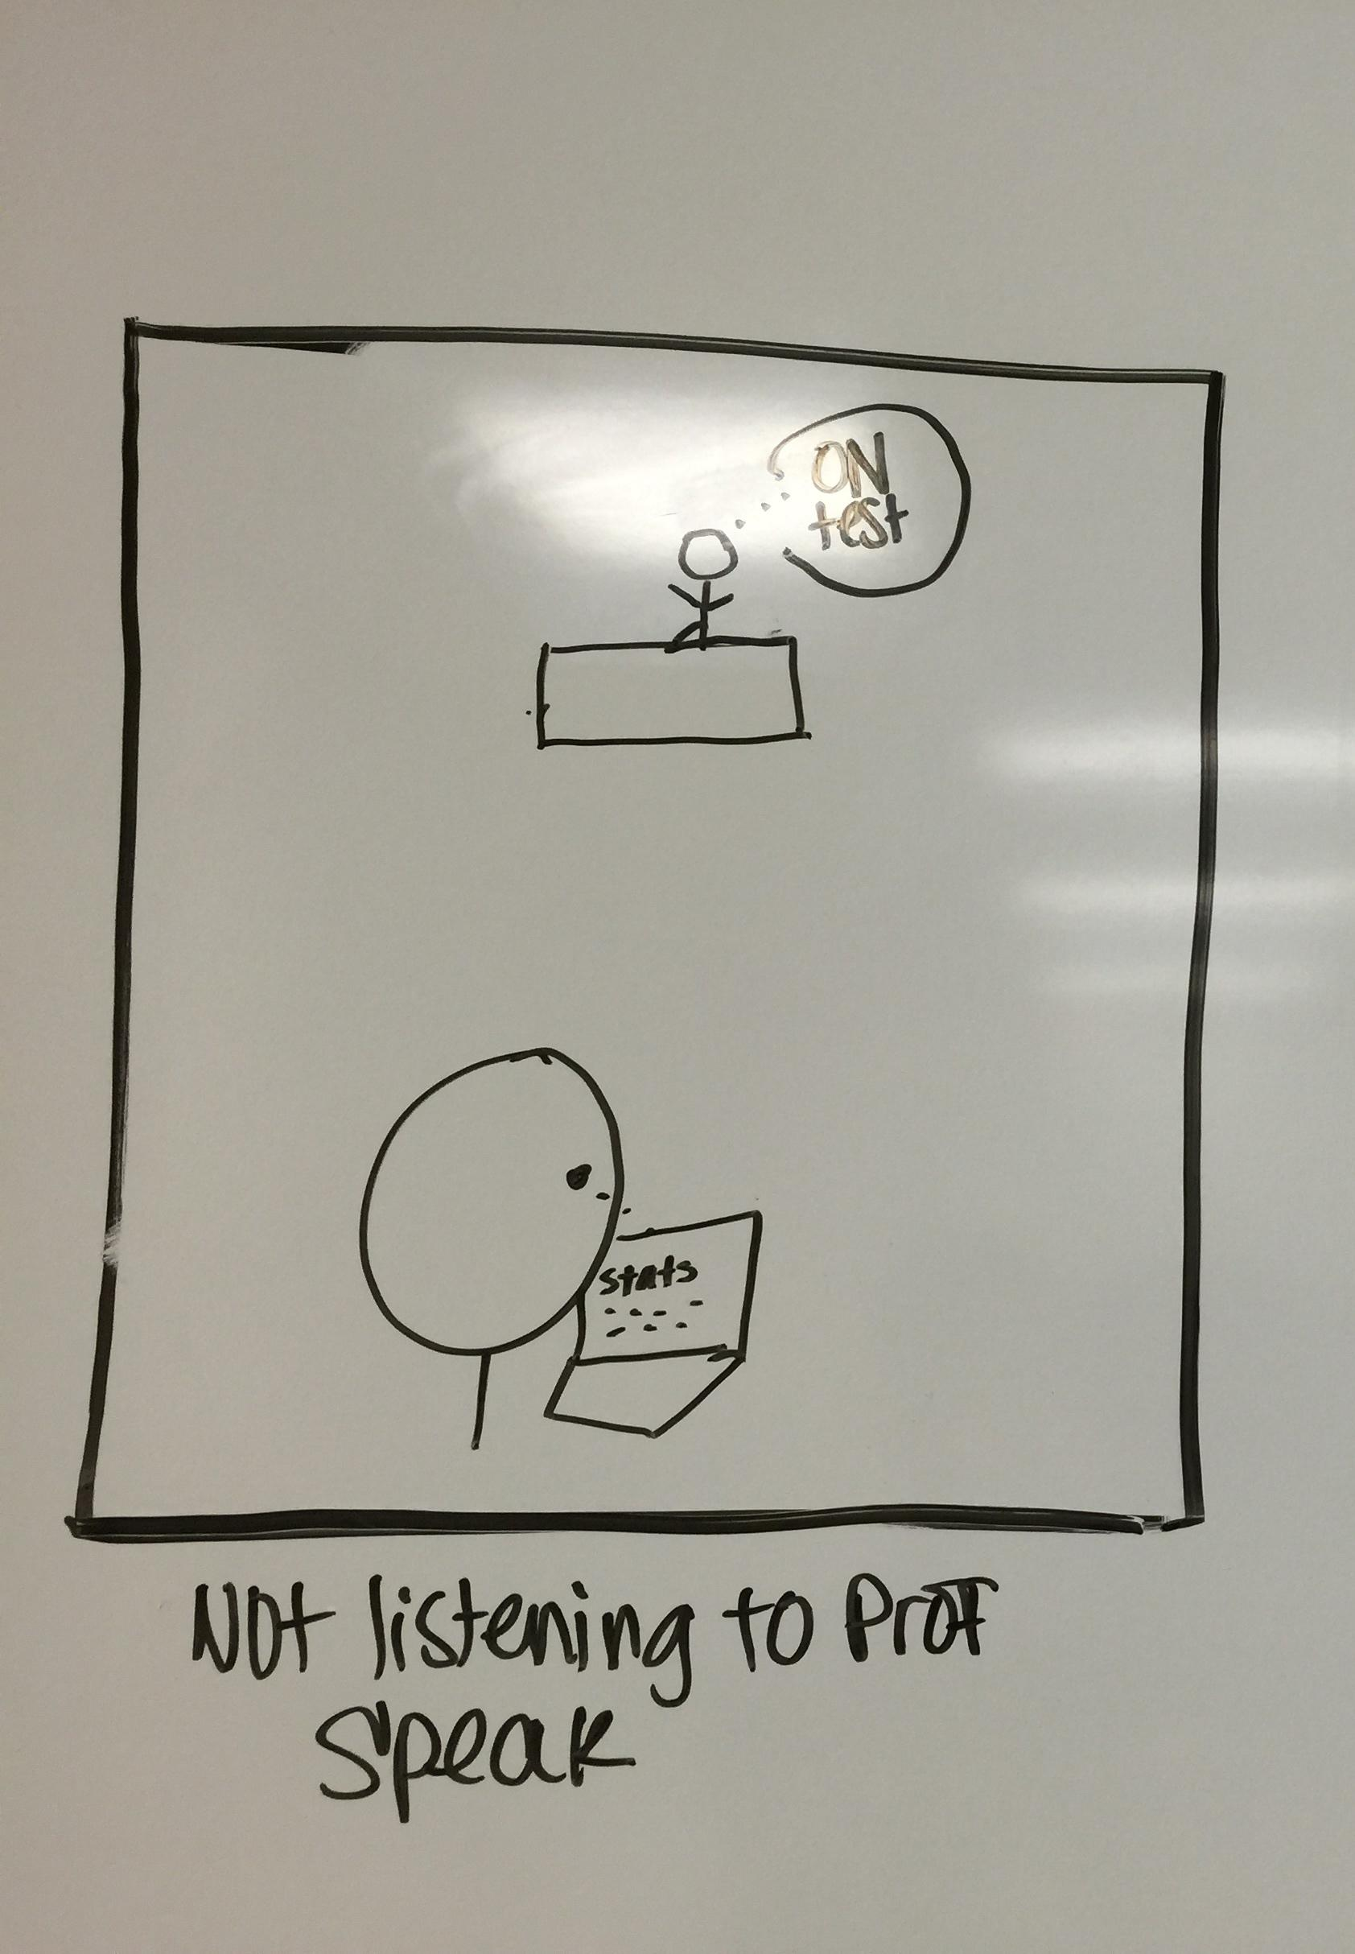

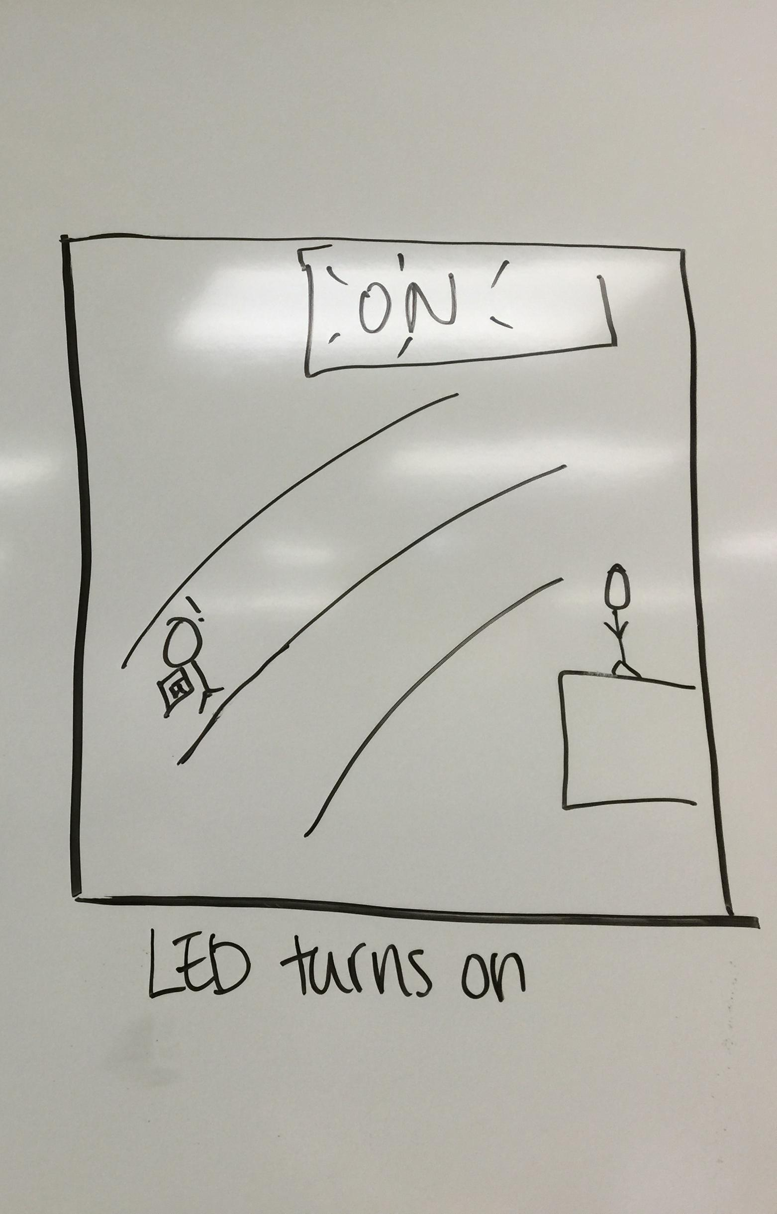

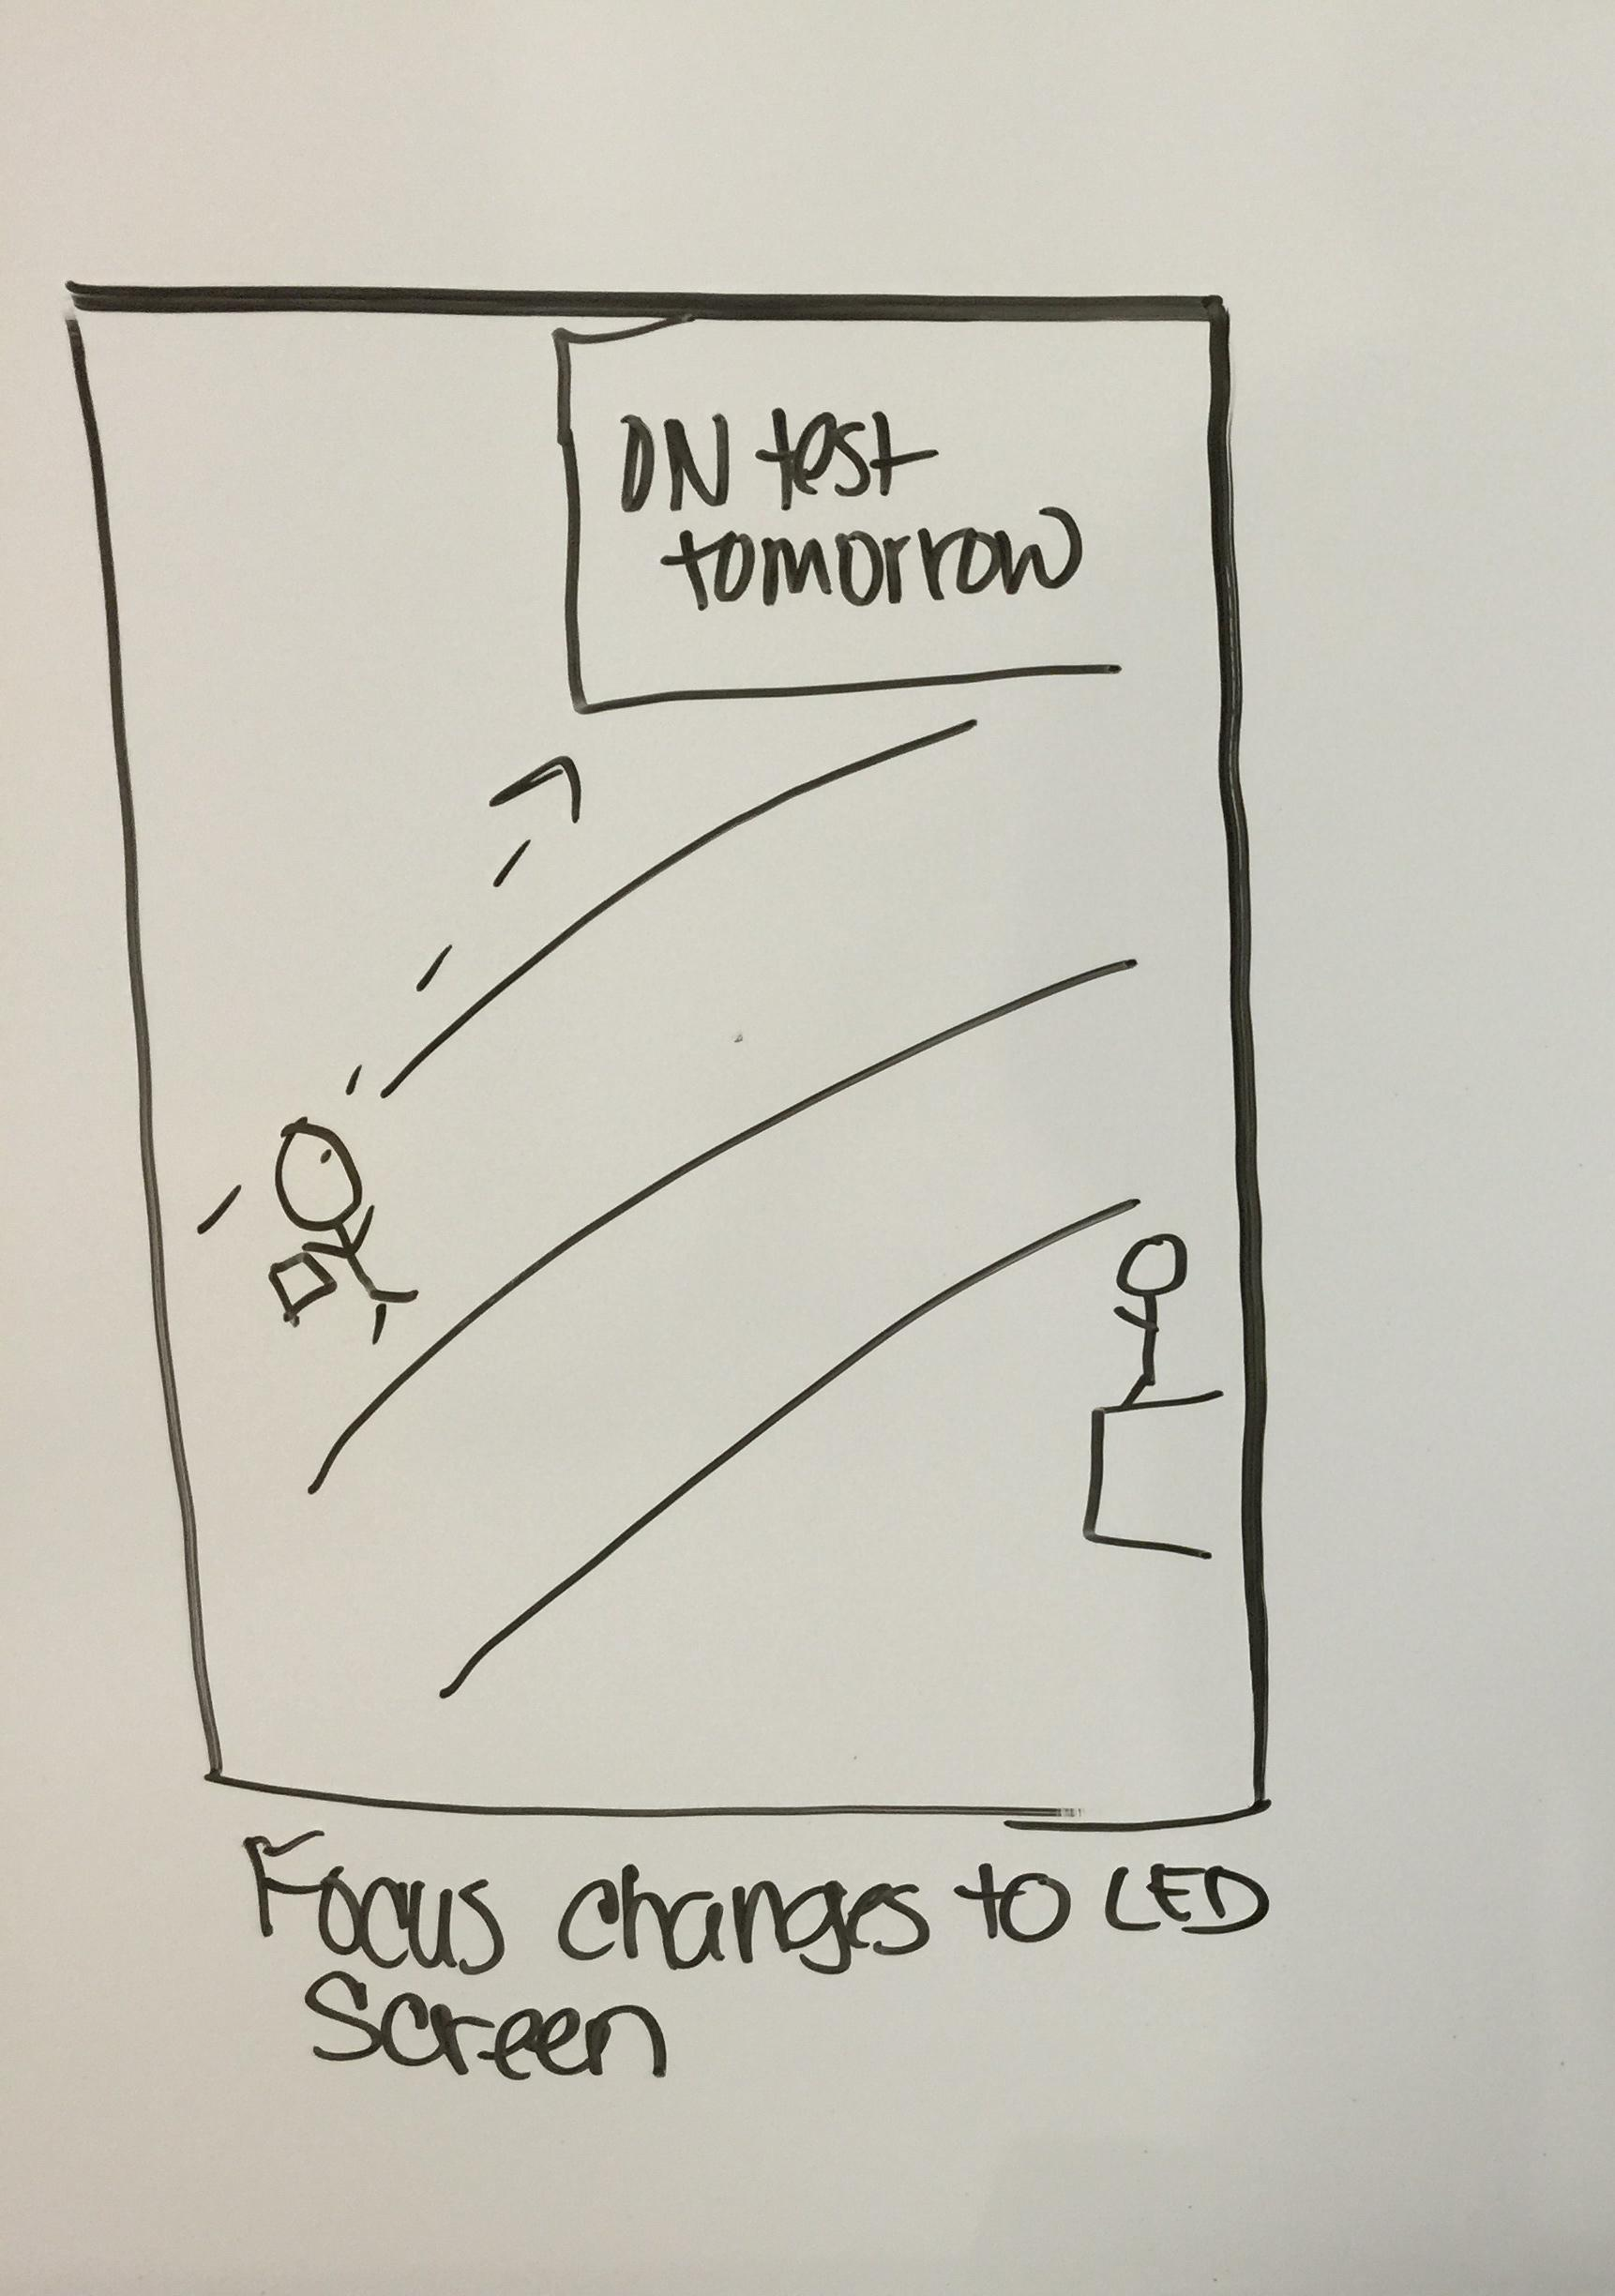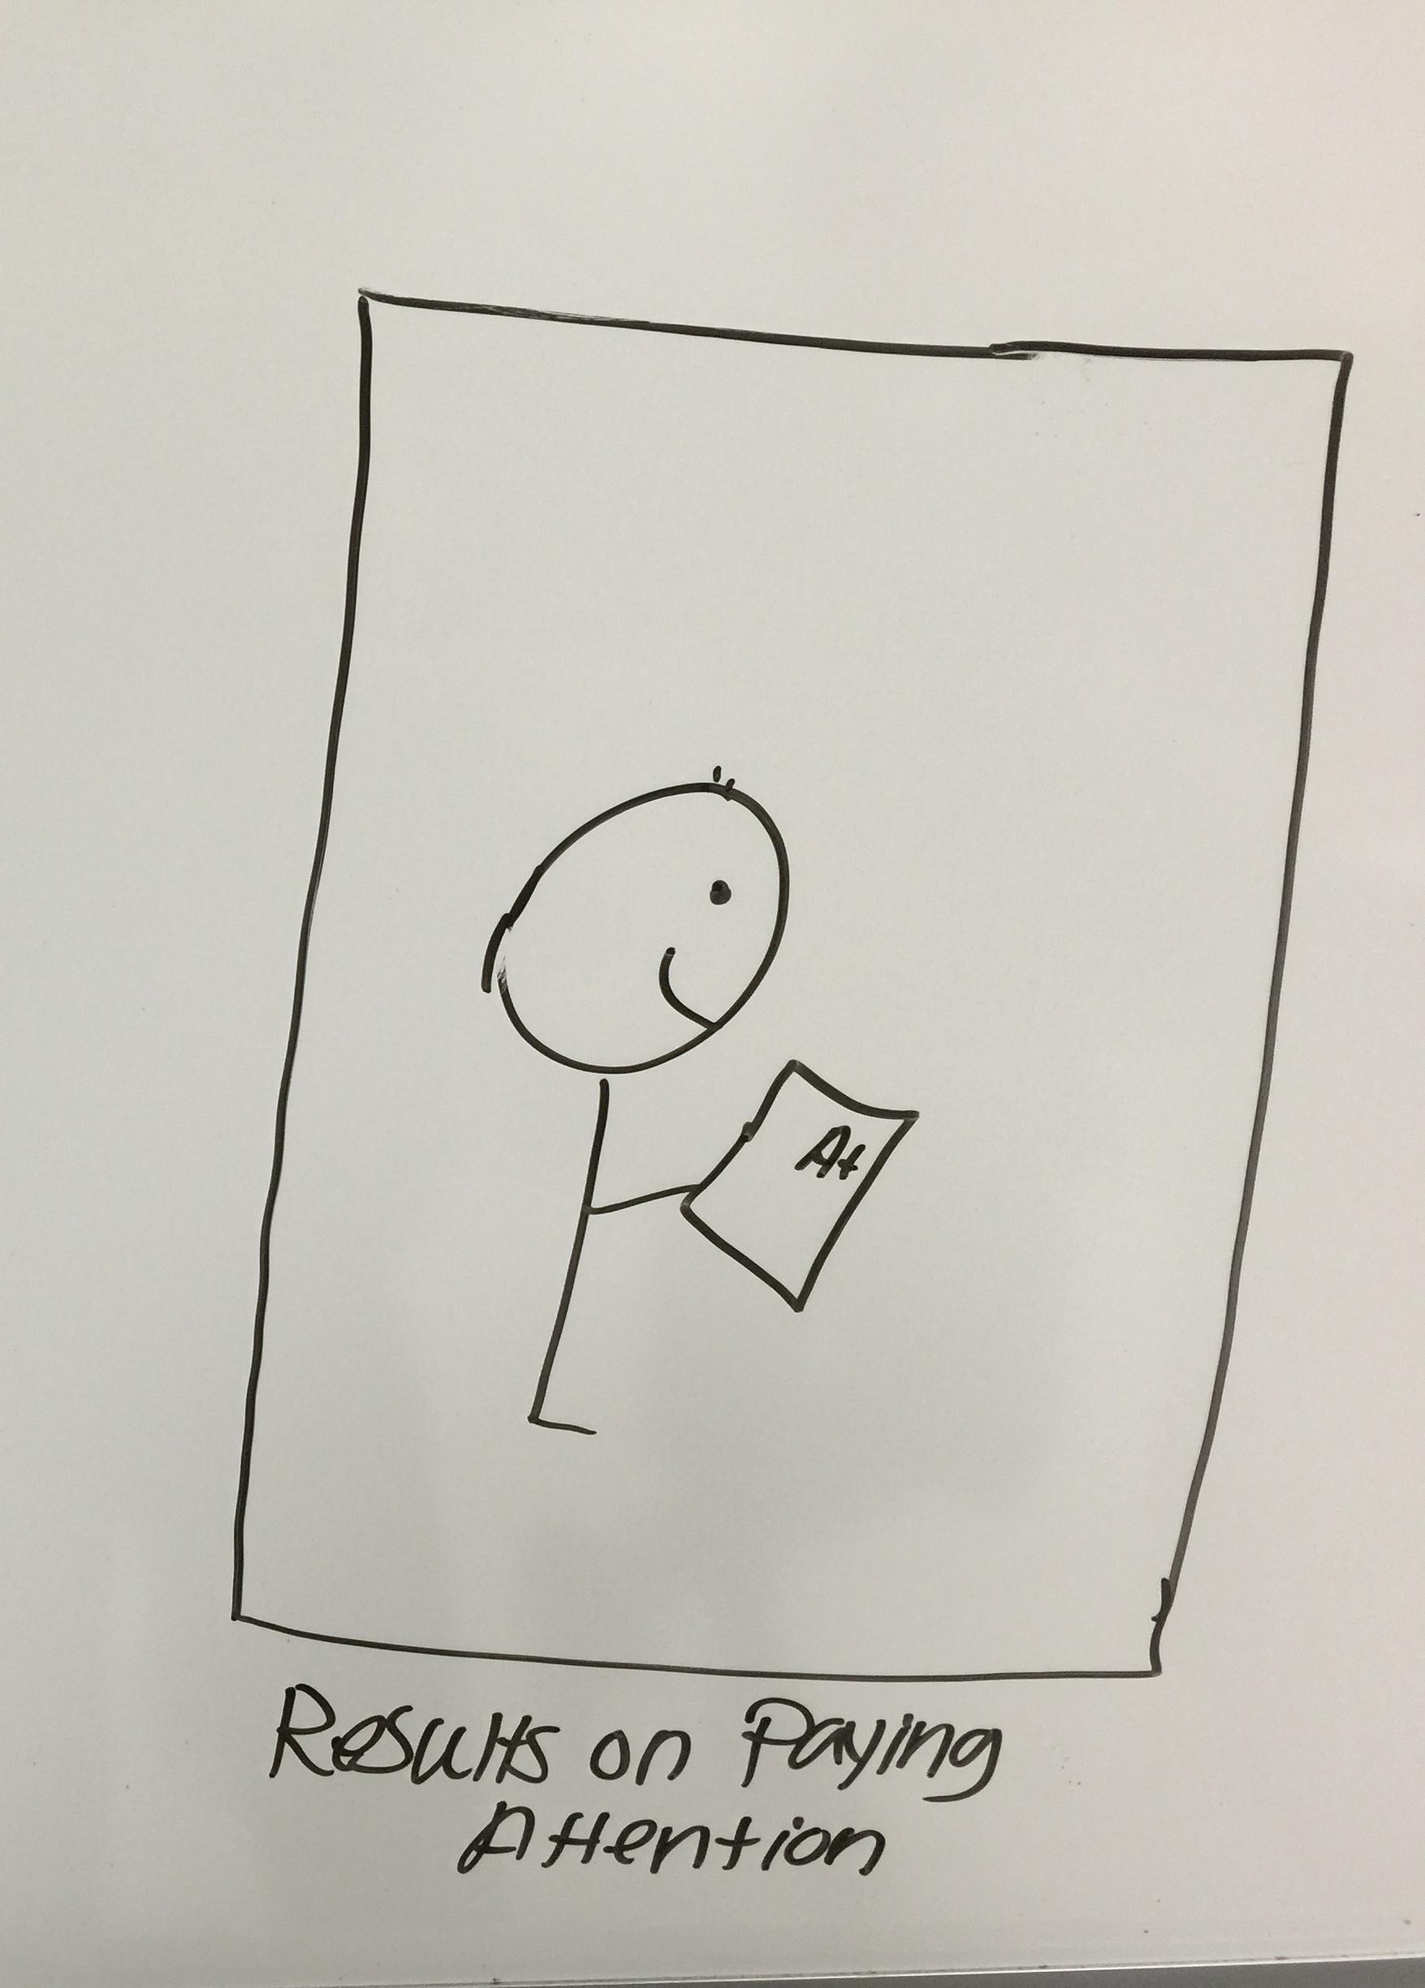

The above storyboard is drawn with the persona Paul used as a model for behaviors. Paul is easily distracted by the multitude of other projects and homework from other classes that he is working on. The large LED screens grab his attention and keeps him engaged throughout the lecture.

DIAGRAM 2: Solution Two Storyboards

**Storyboard One**

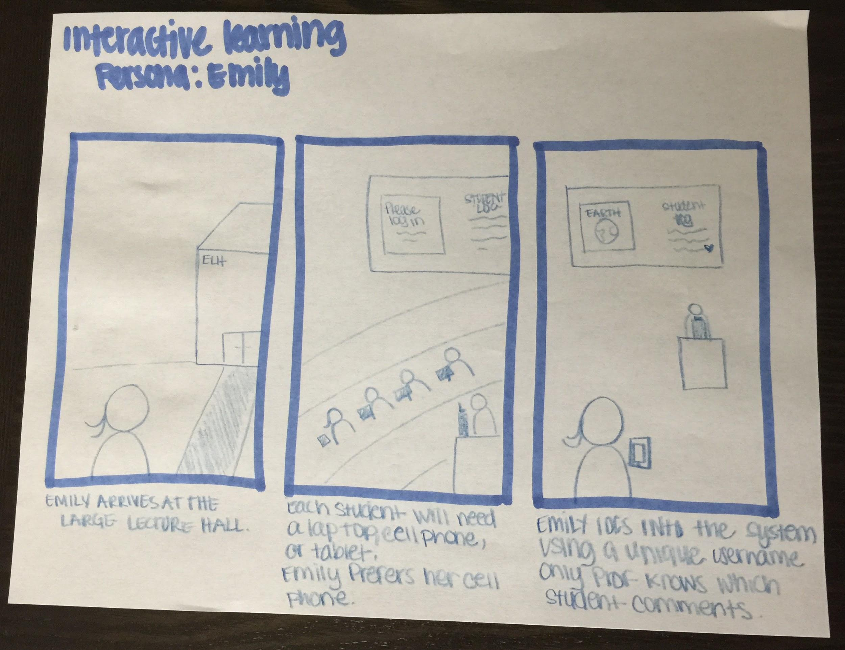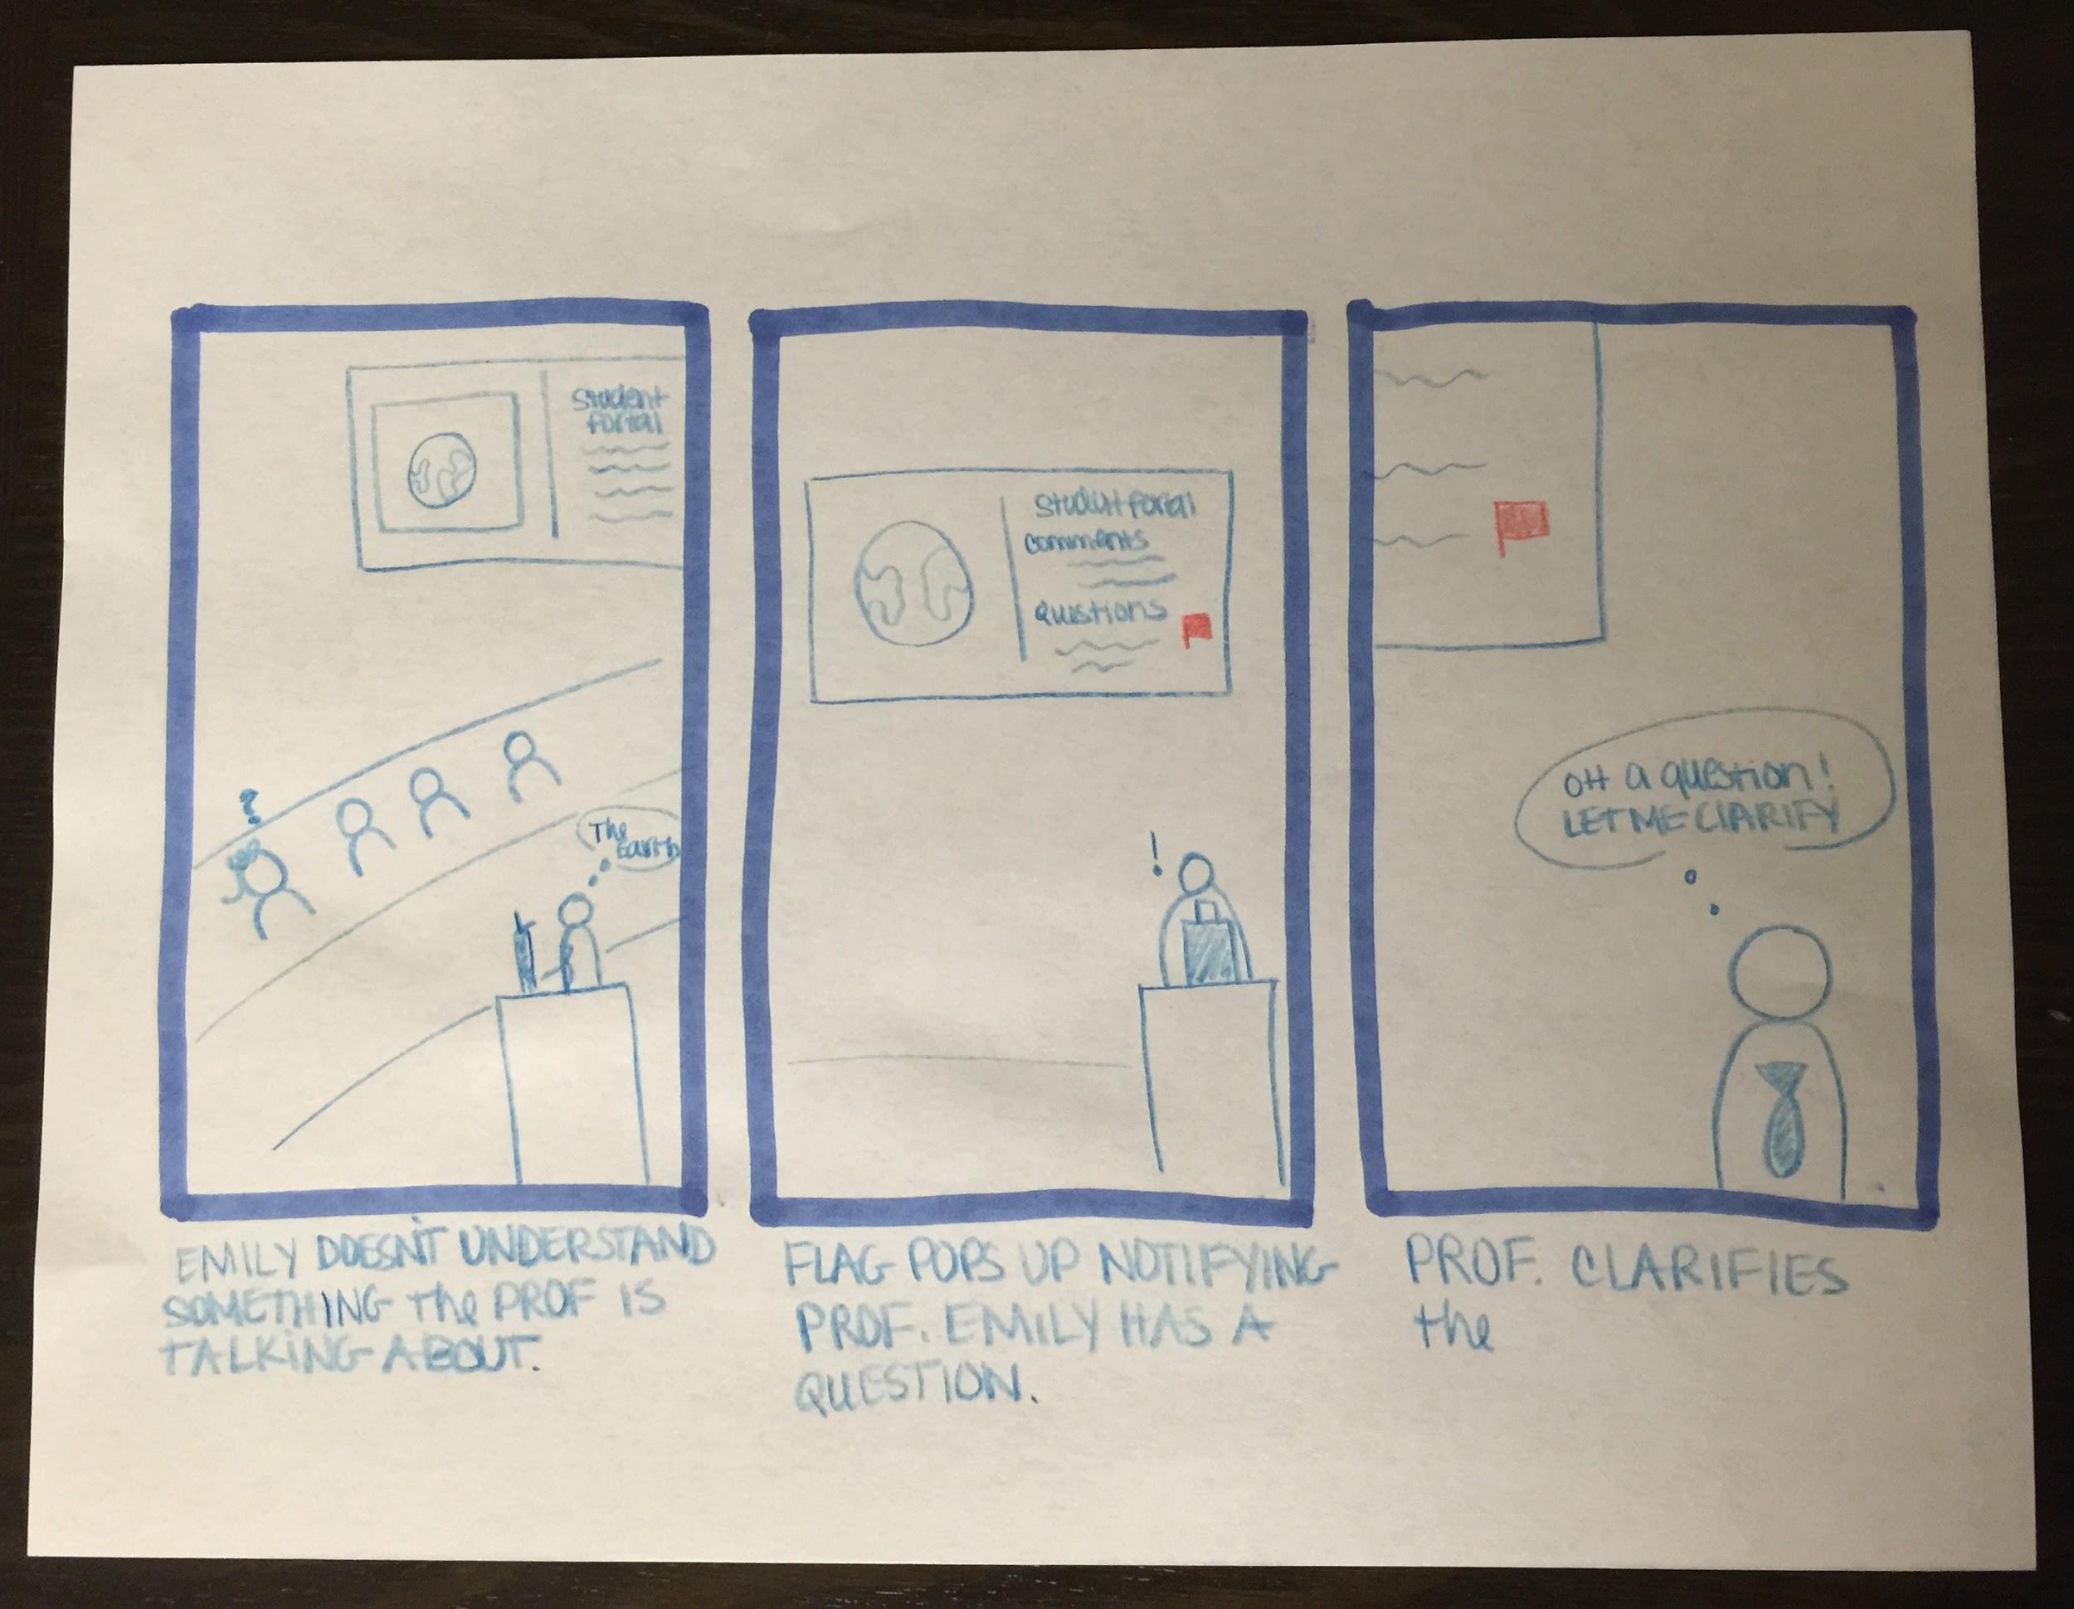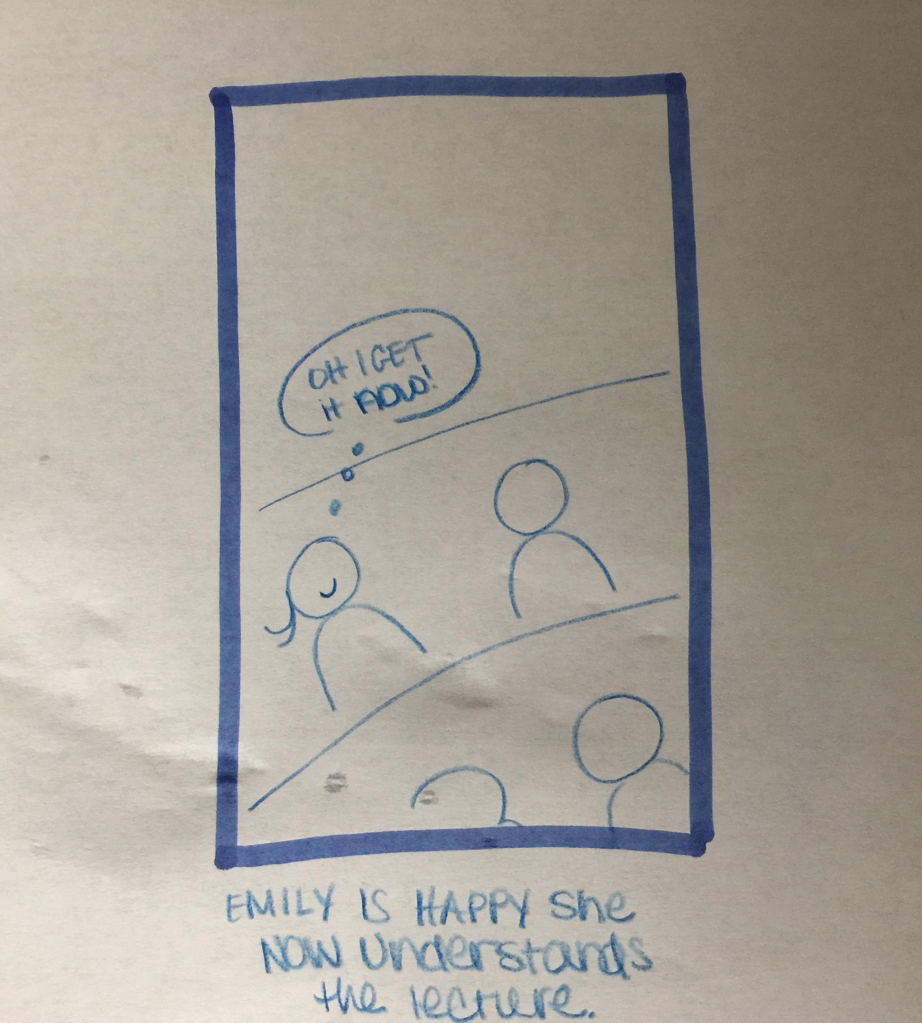

Storyboard one solution two is a high-level depiction of the main flow of events a user would go through when interacting with the “interactive” learning system. It shows Emily using the system, when she does not understand what the professor is explaining she is allowed “raise a flag” notifying the professor that there is student that has a question. This allows students who are too shy, or too far in the back to ask questions.

**Storyboard Two**

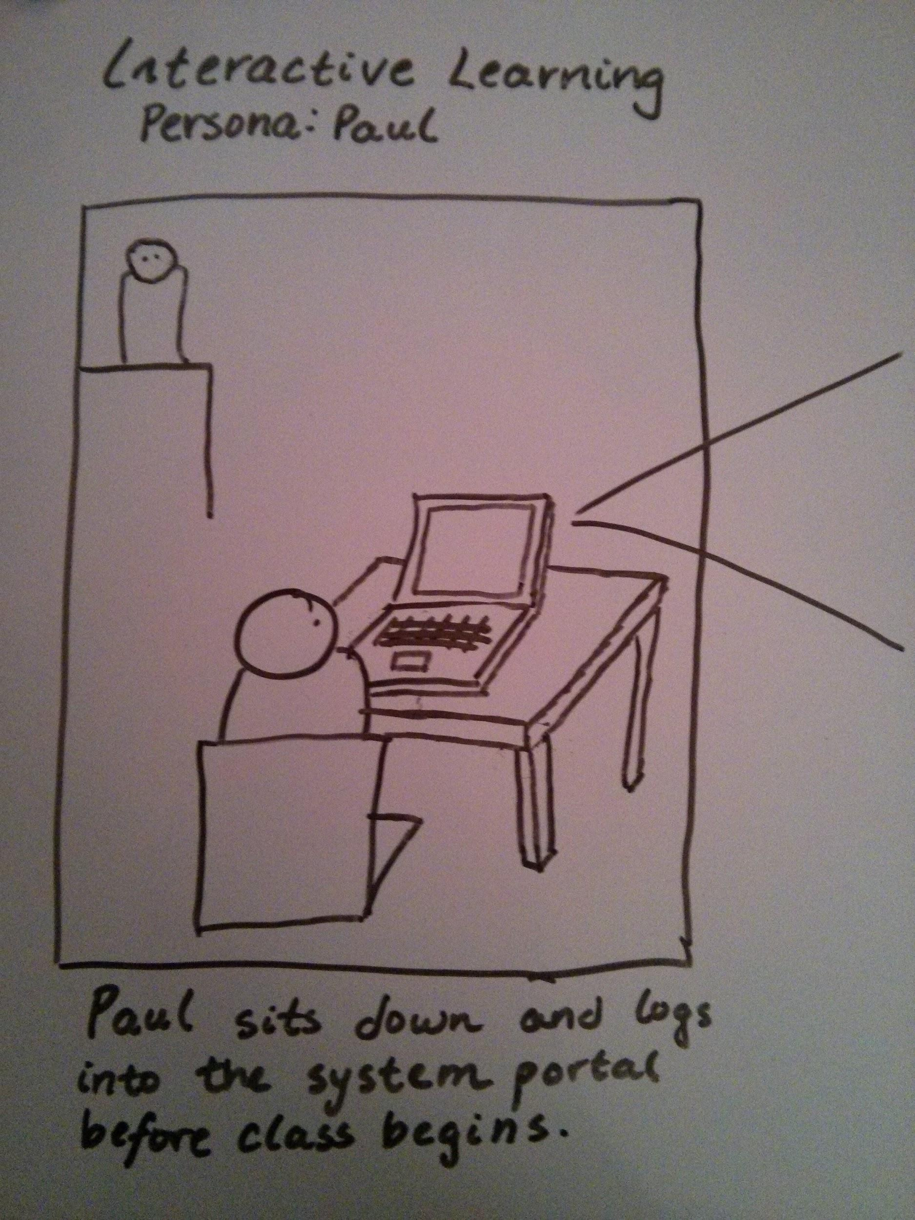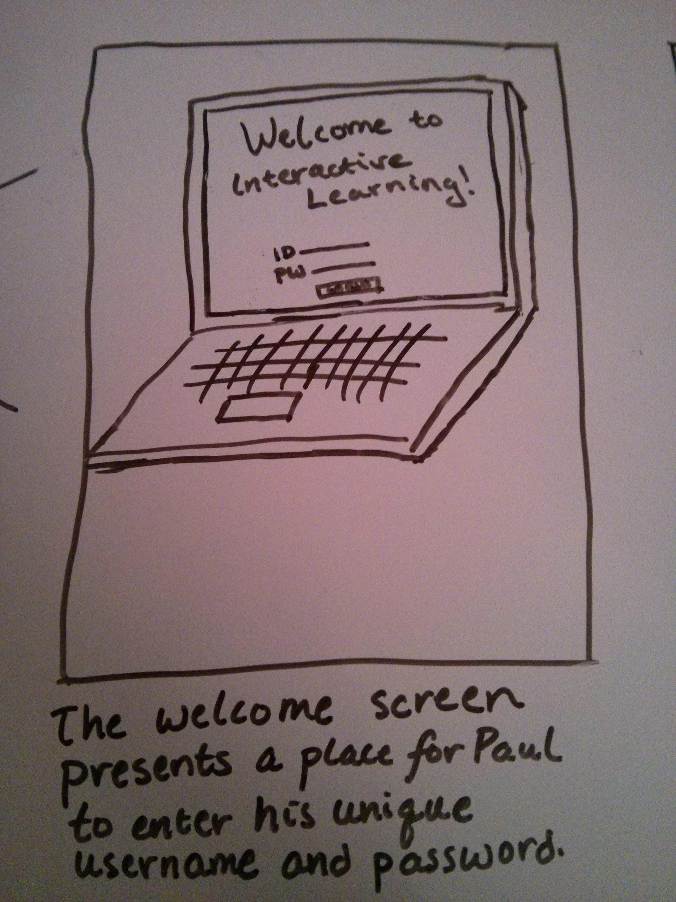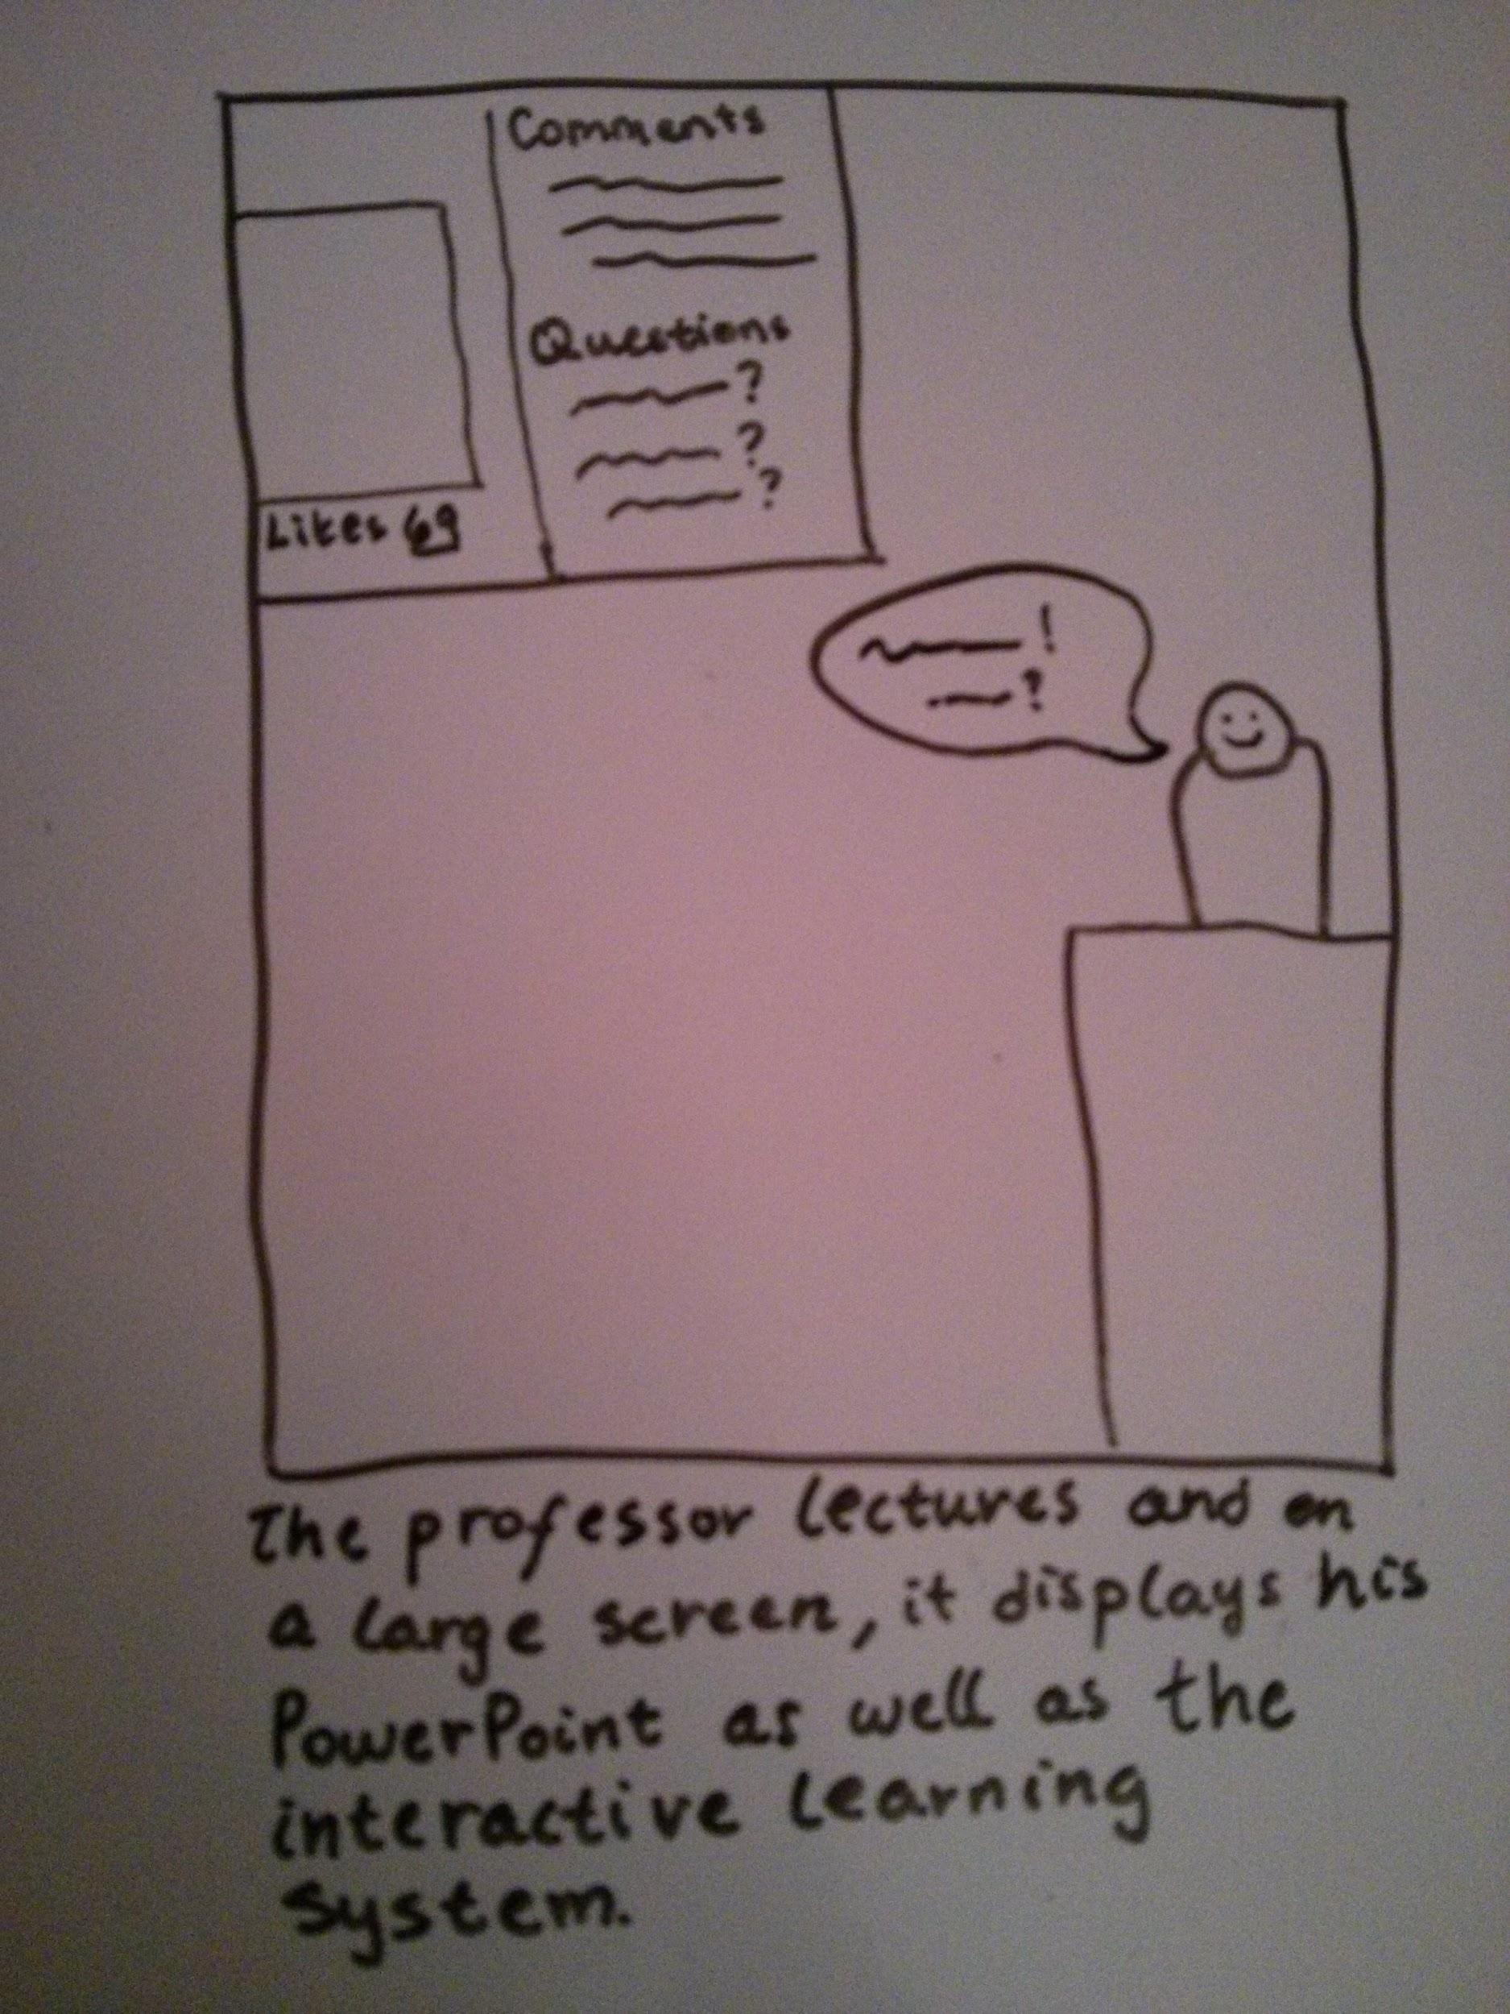

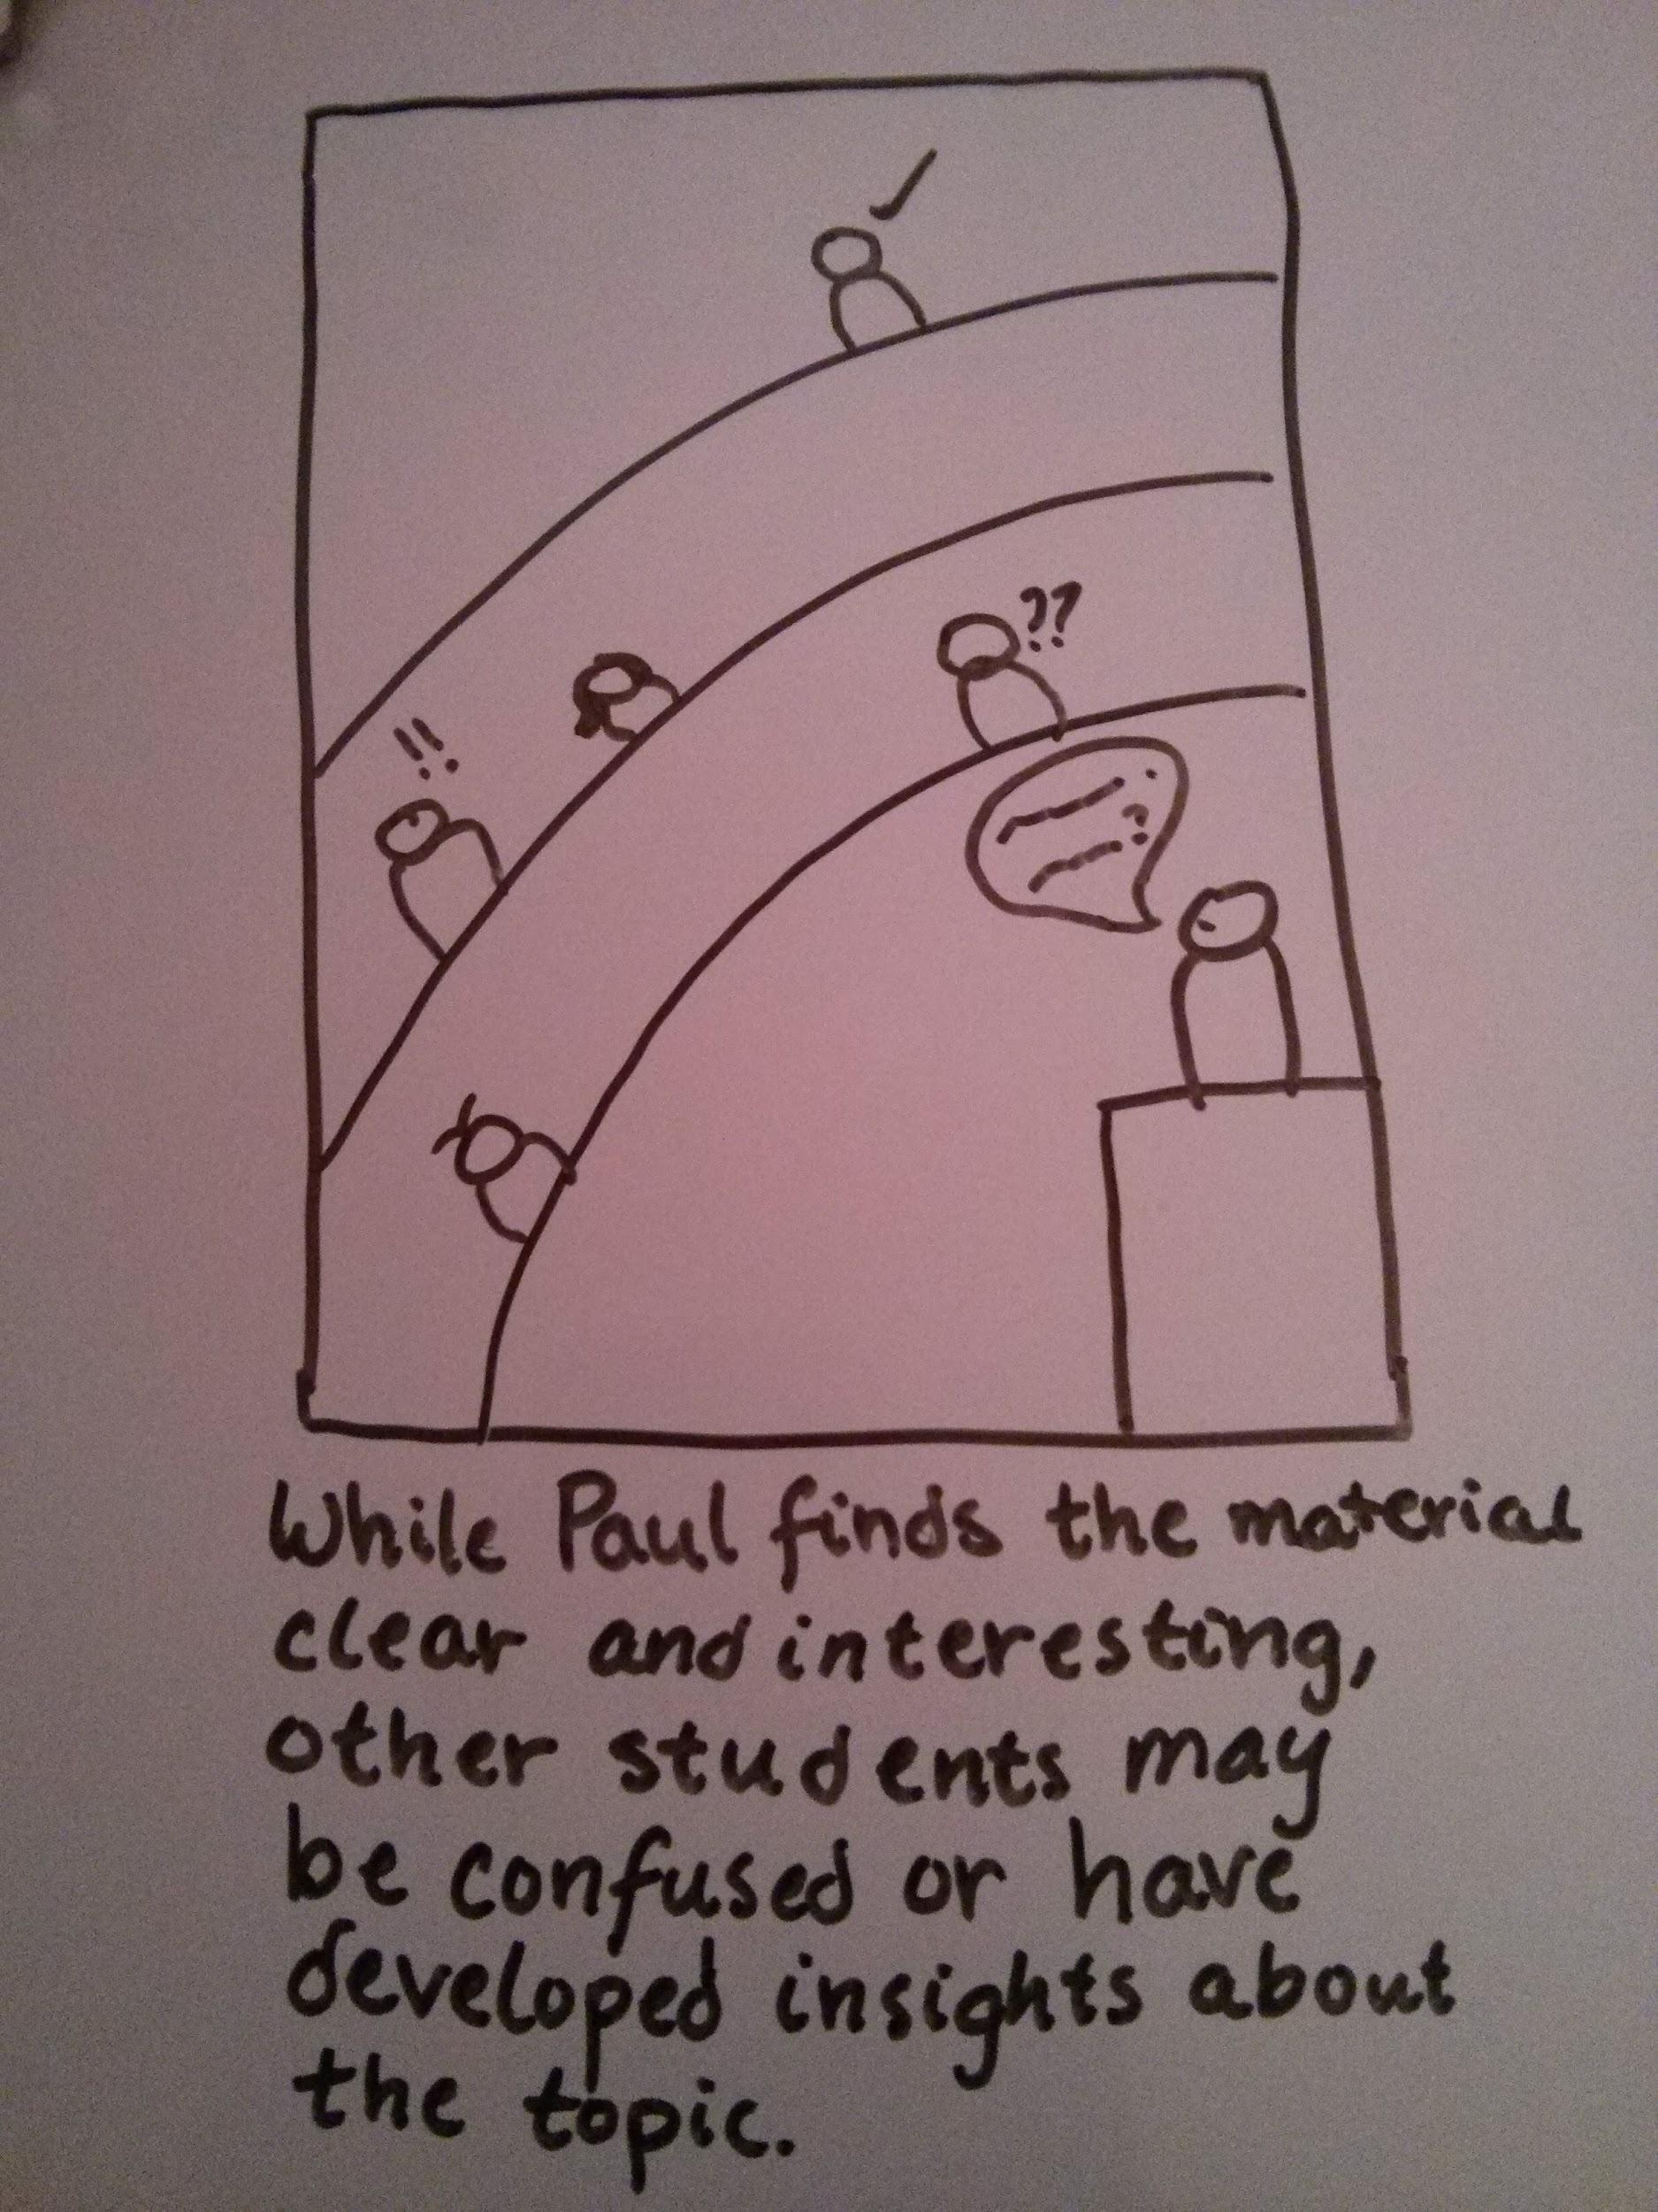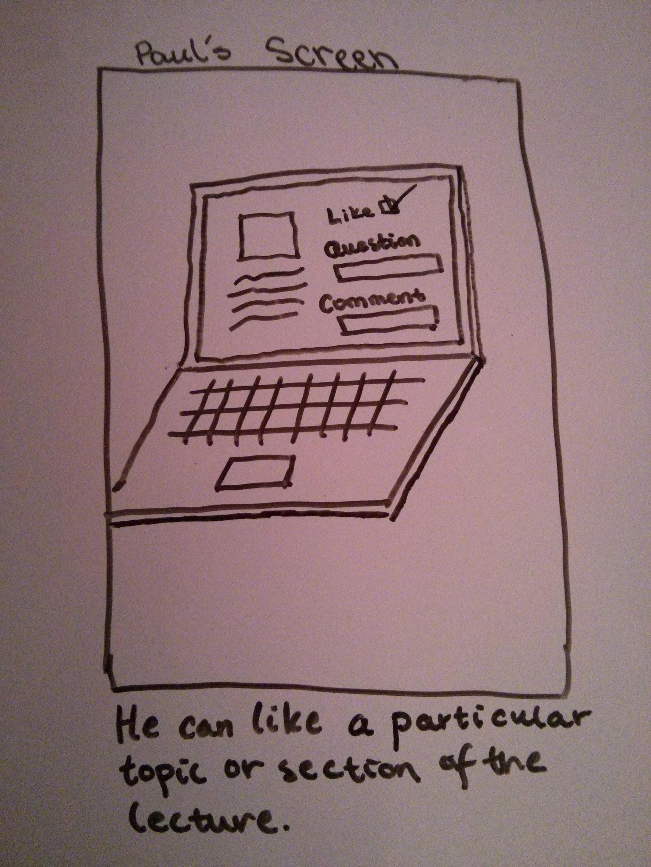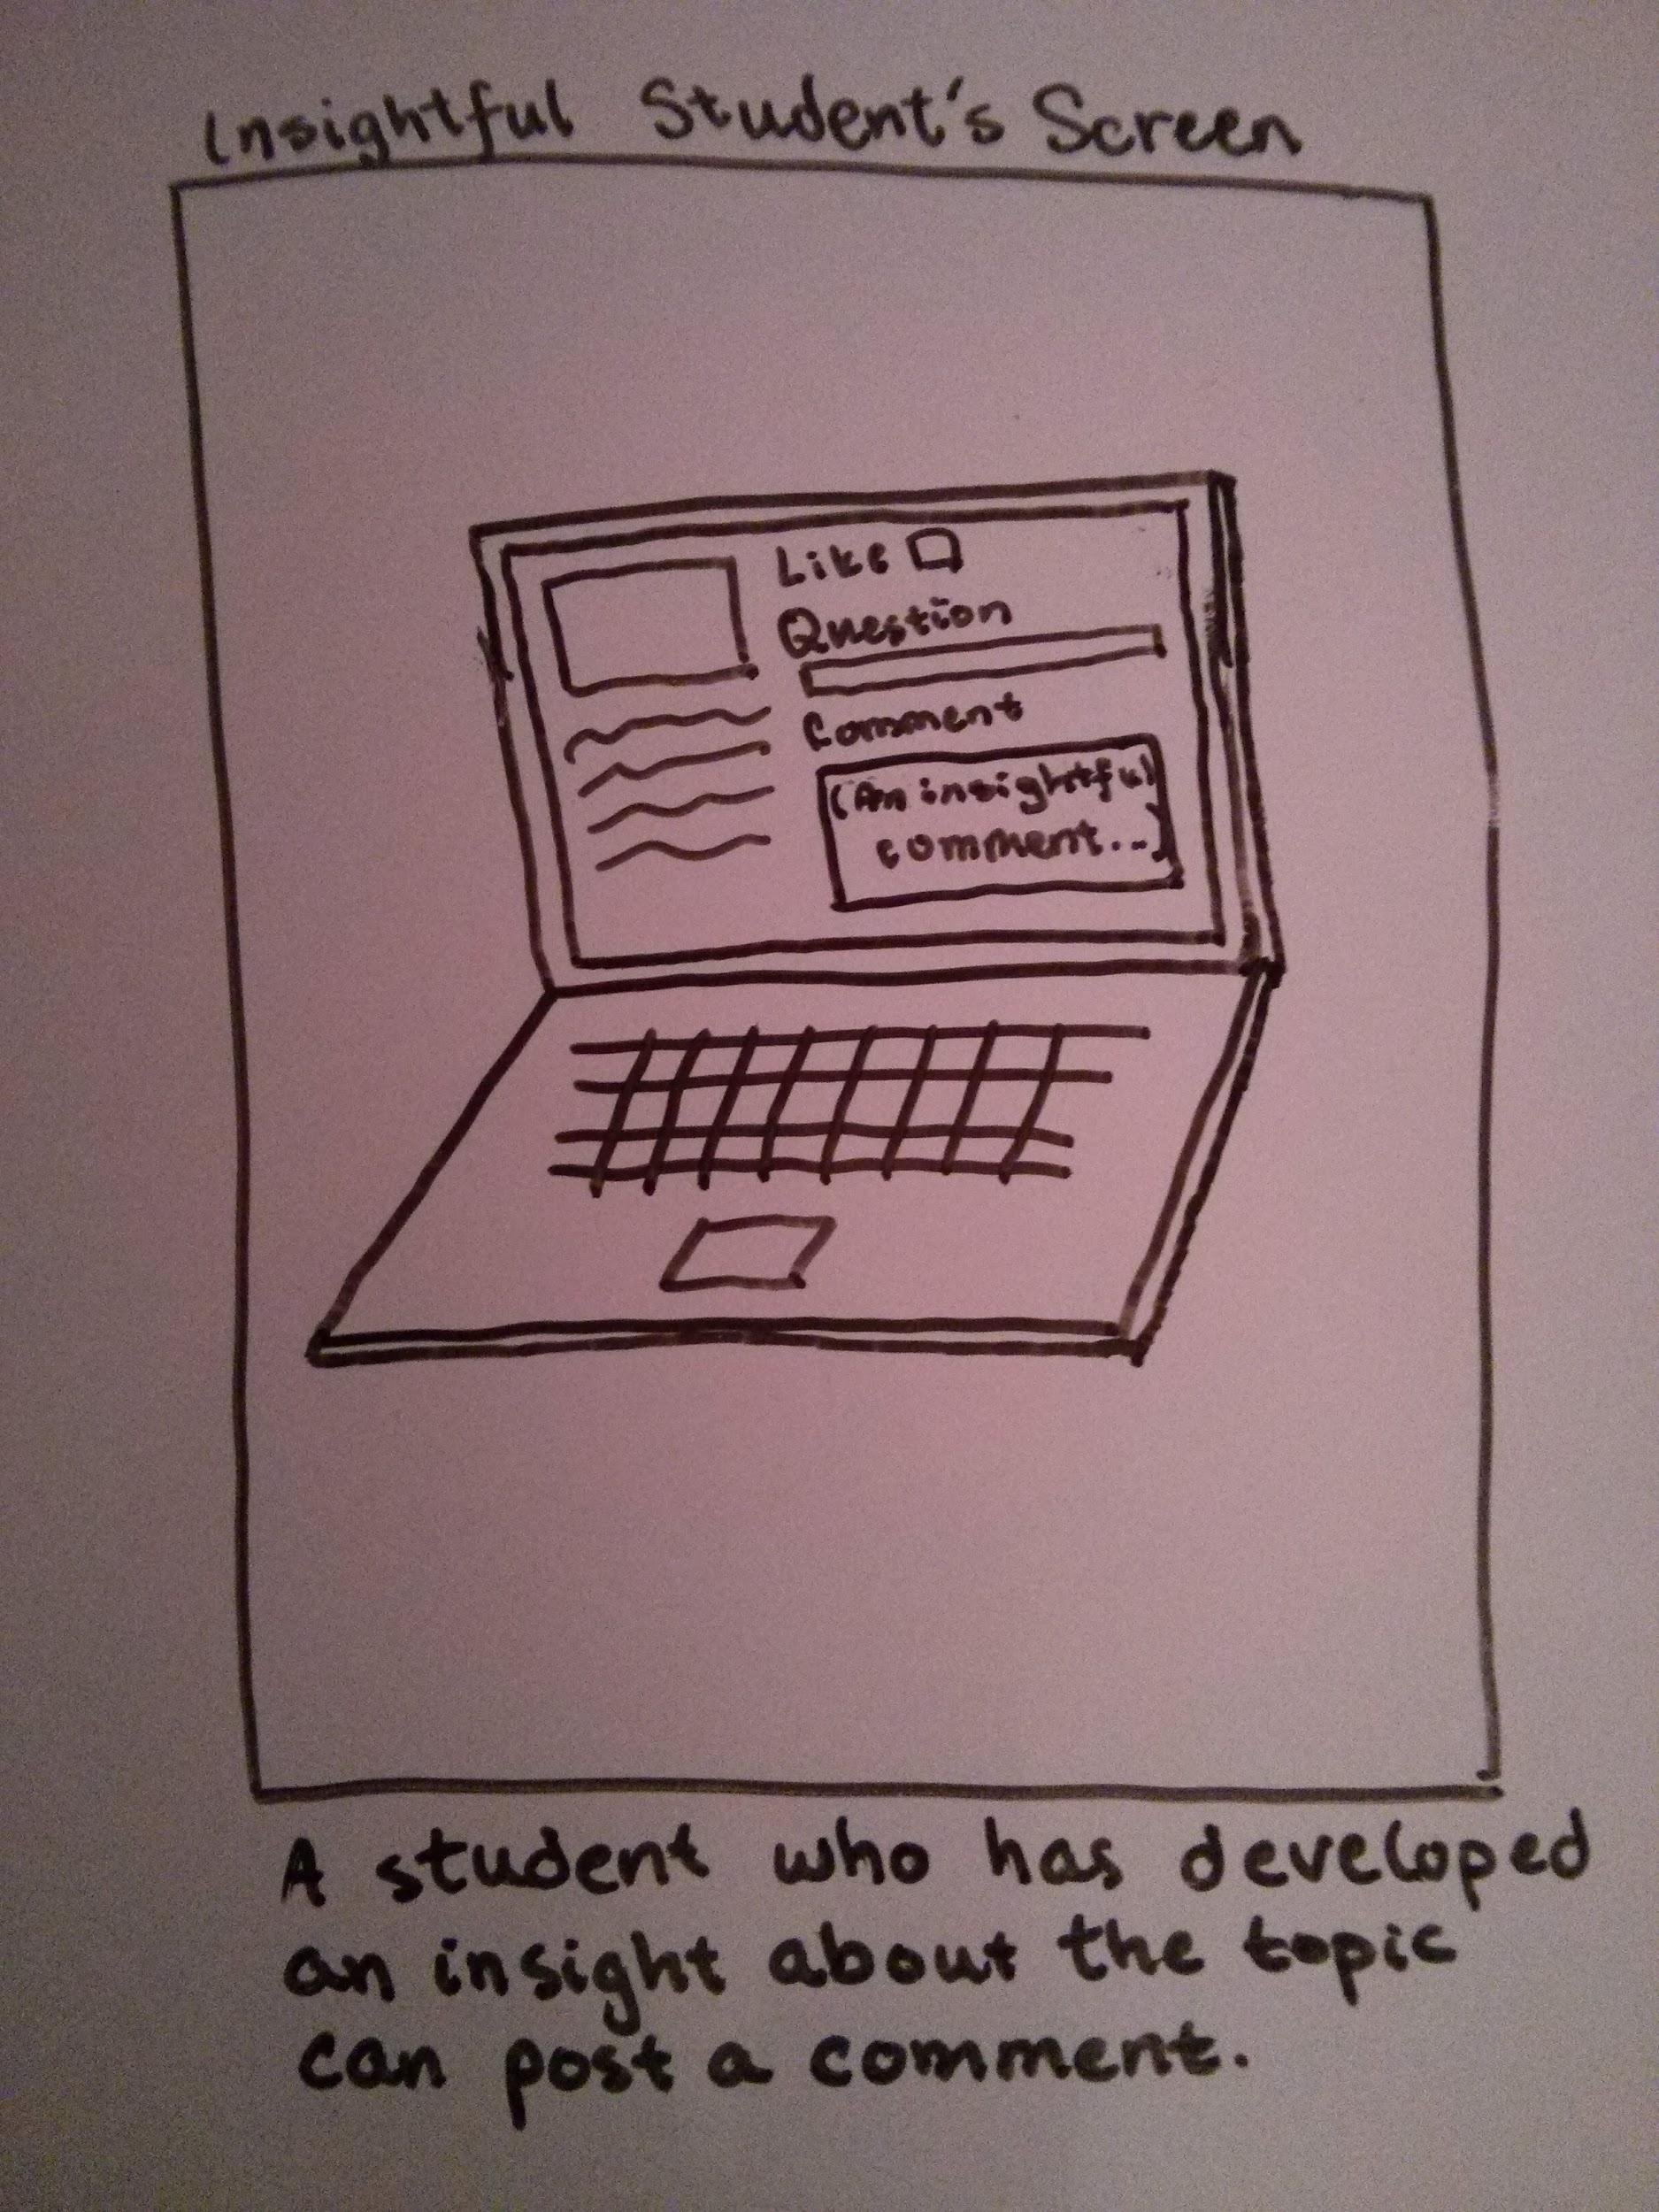

Storyboard for Solution Two follows Paul’s screen as he attends a lecture. When Paul first starts up the system, he is prompted to enter in his unique username and password. Then as the lecture progresses, the interactive learning system is displayed on a large screen behind the professor. The professor himself/herself has the same screen in front of them, notifying them of when students “like, comment, or question” something that was posted. Paul is able to “Like” a section of the lecture he finds interesting or particularly clear. Other students are also able to comment or ask a question and that would be displayed to the professor on their own screen as well as on the large screen.

DIAGRAM 3: Solution Three Storyboards

**Storyboard One (Emily : Games/Reward System)**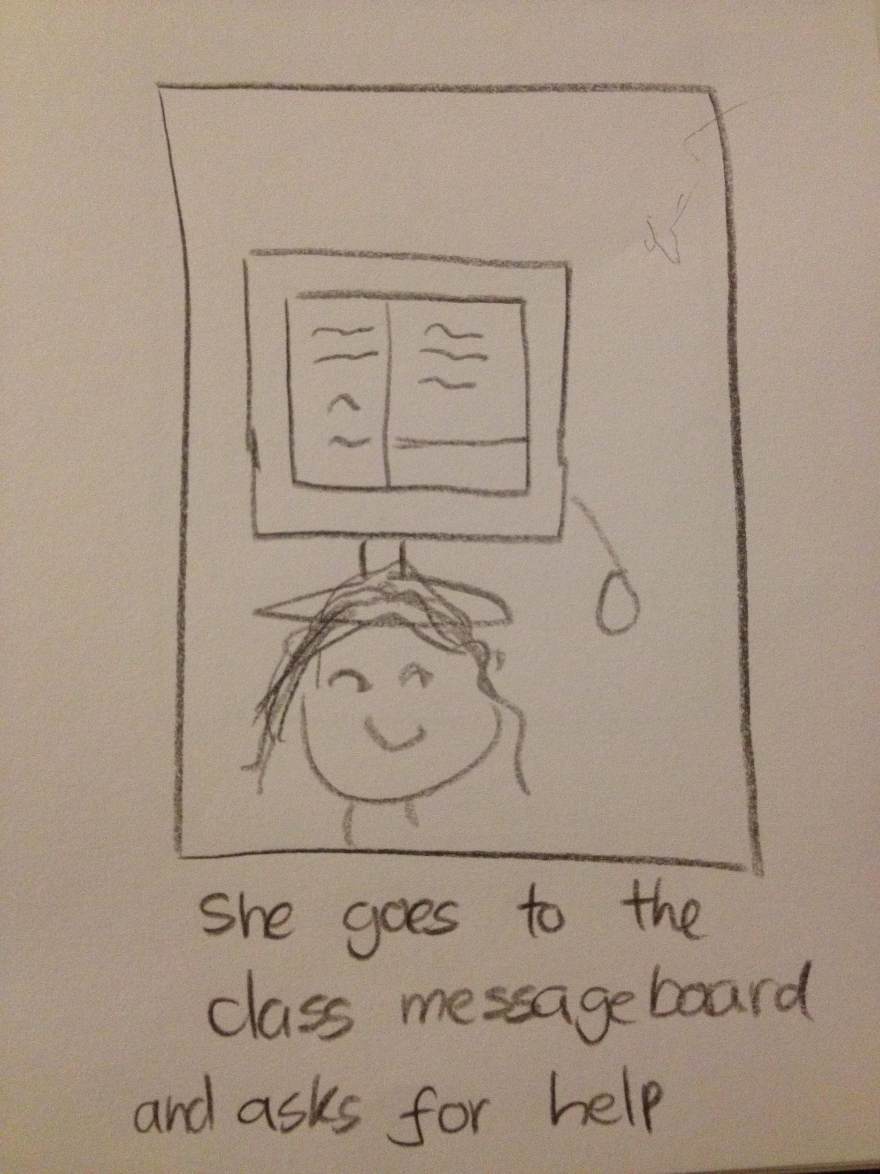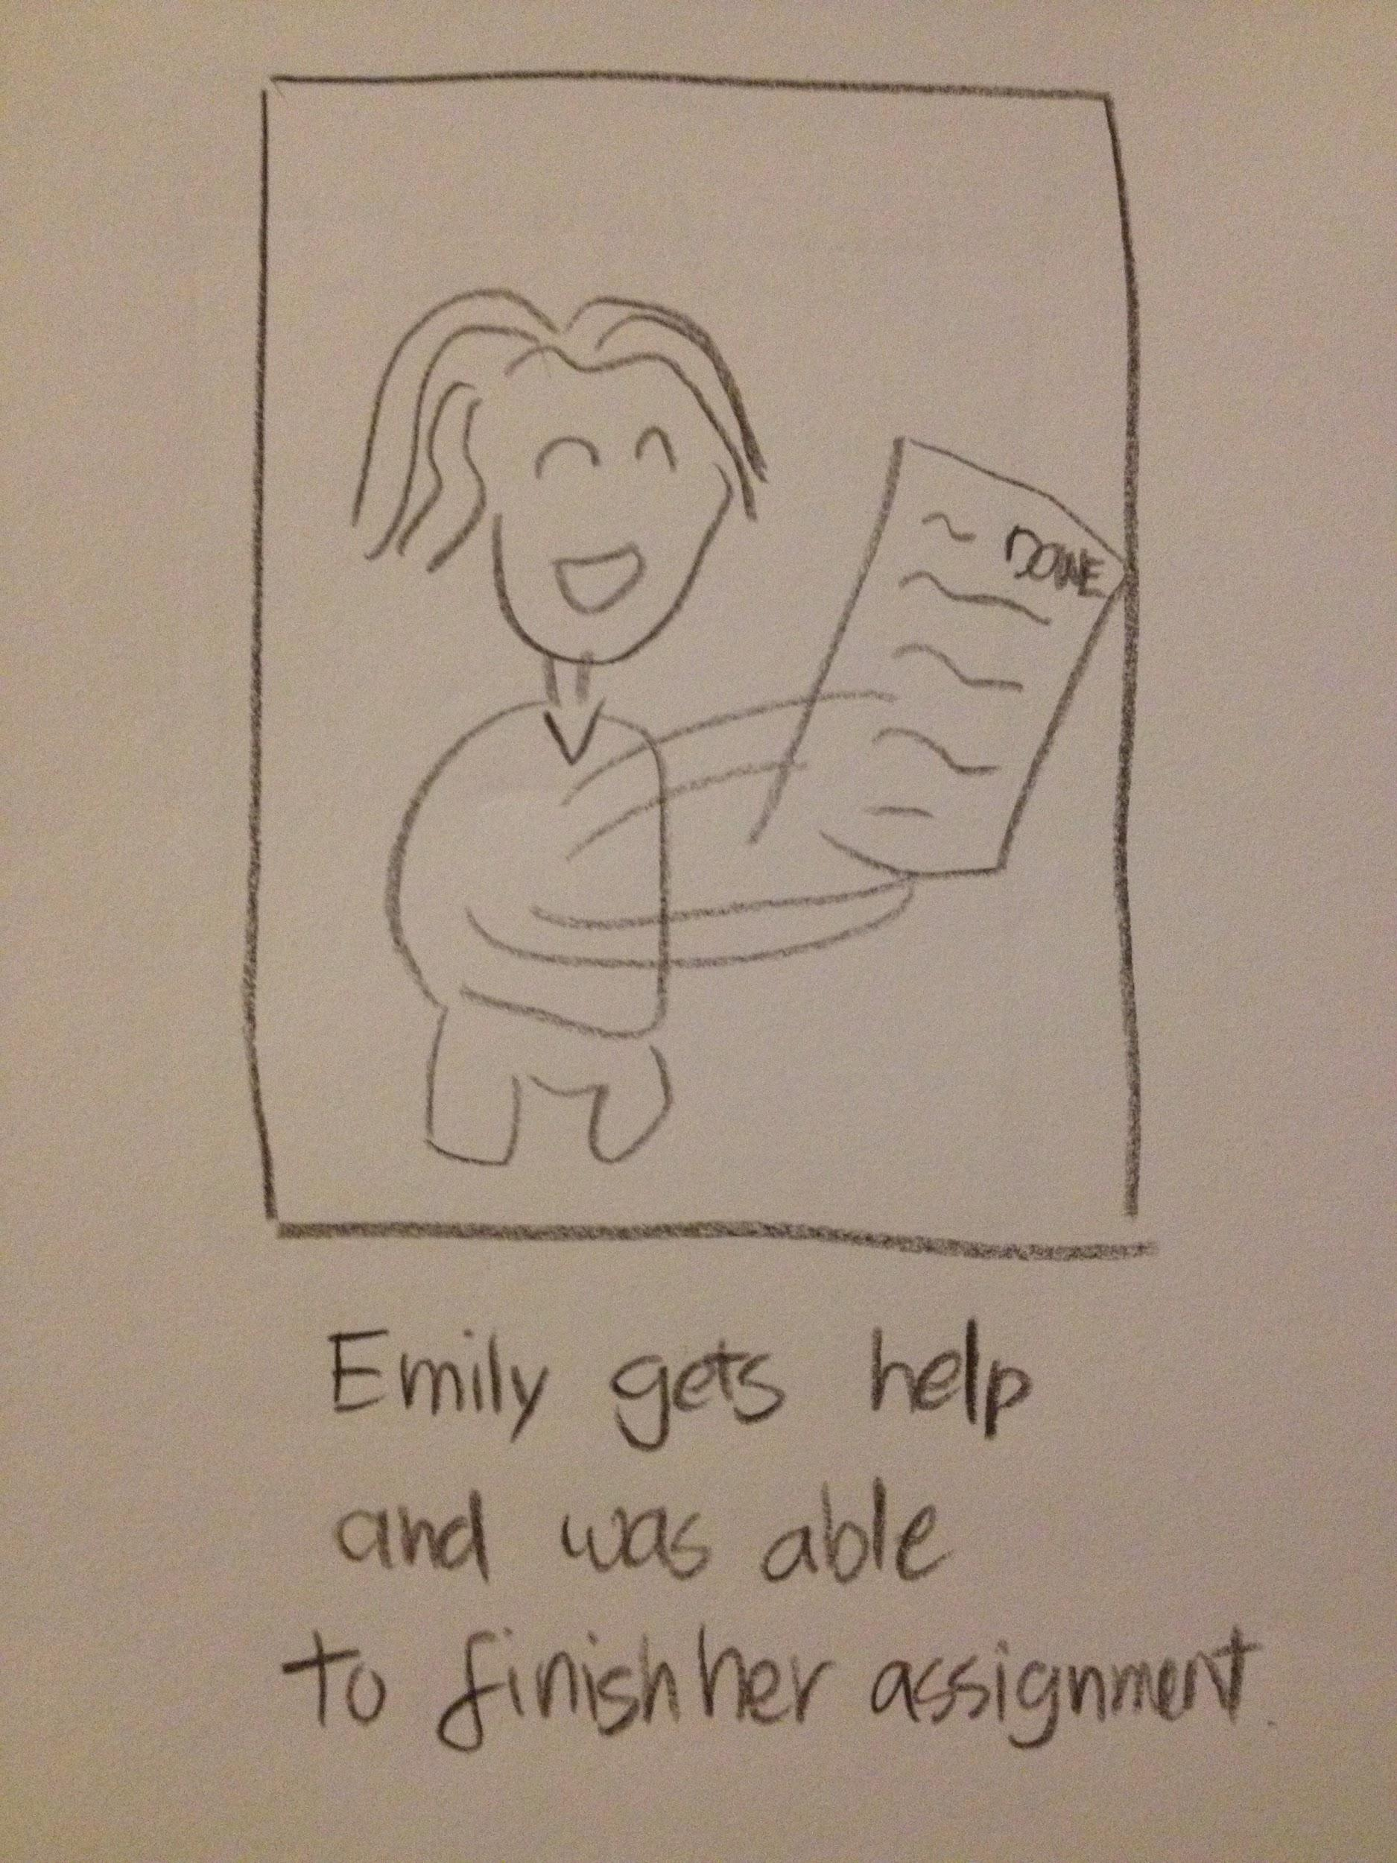

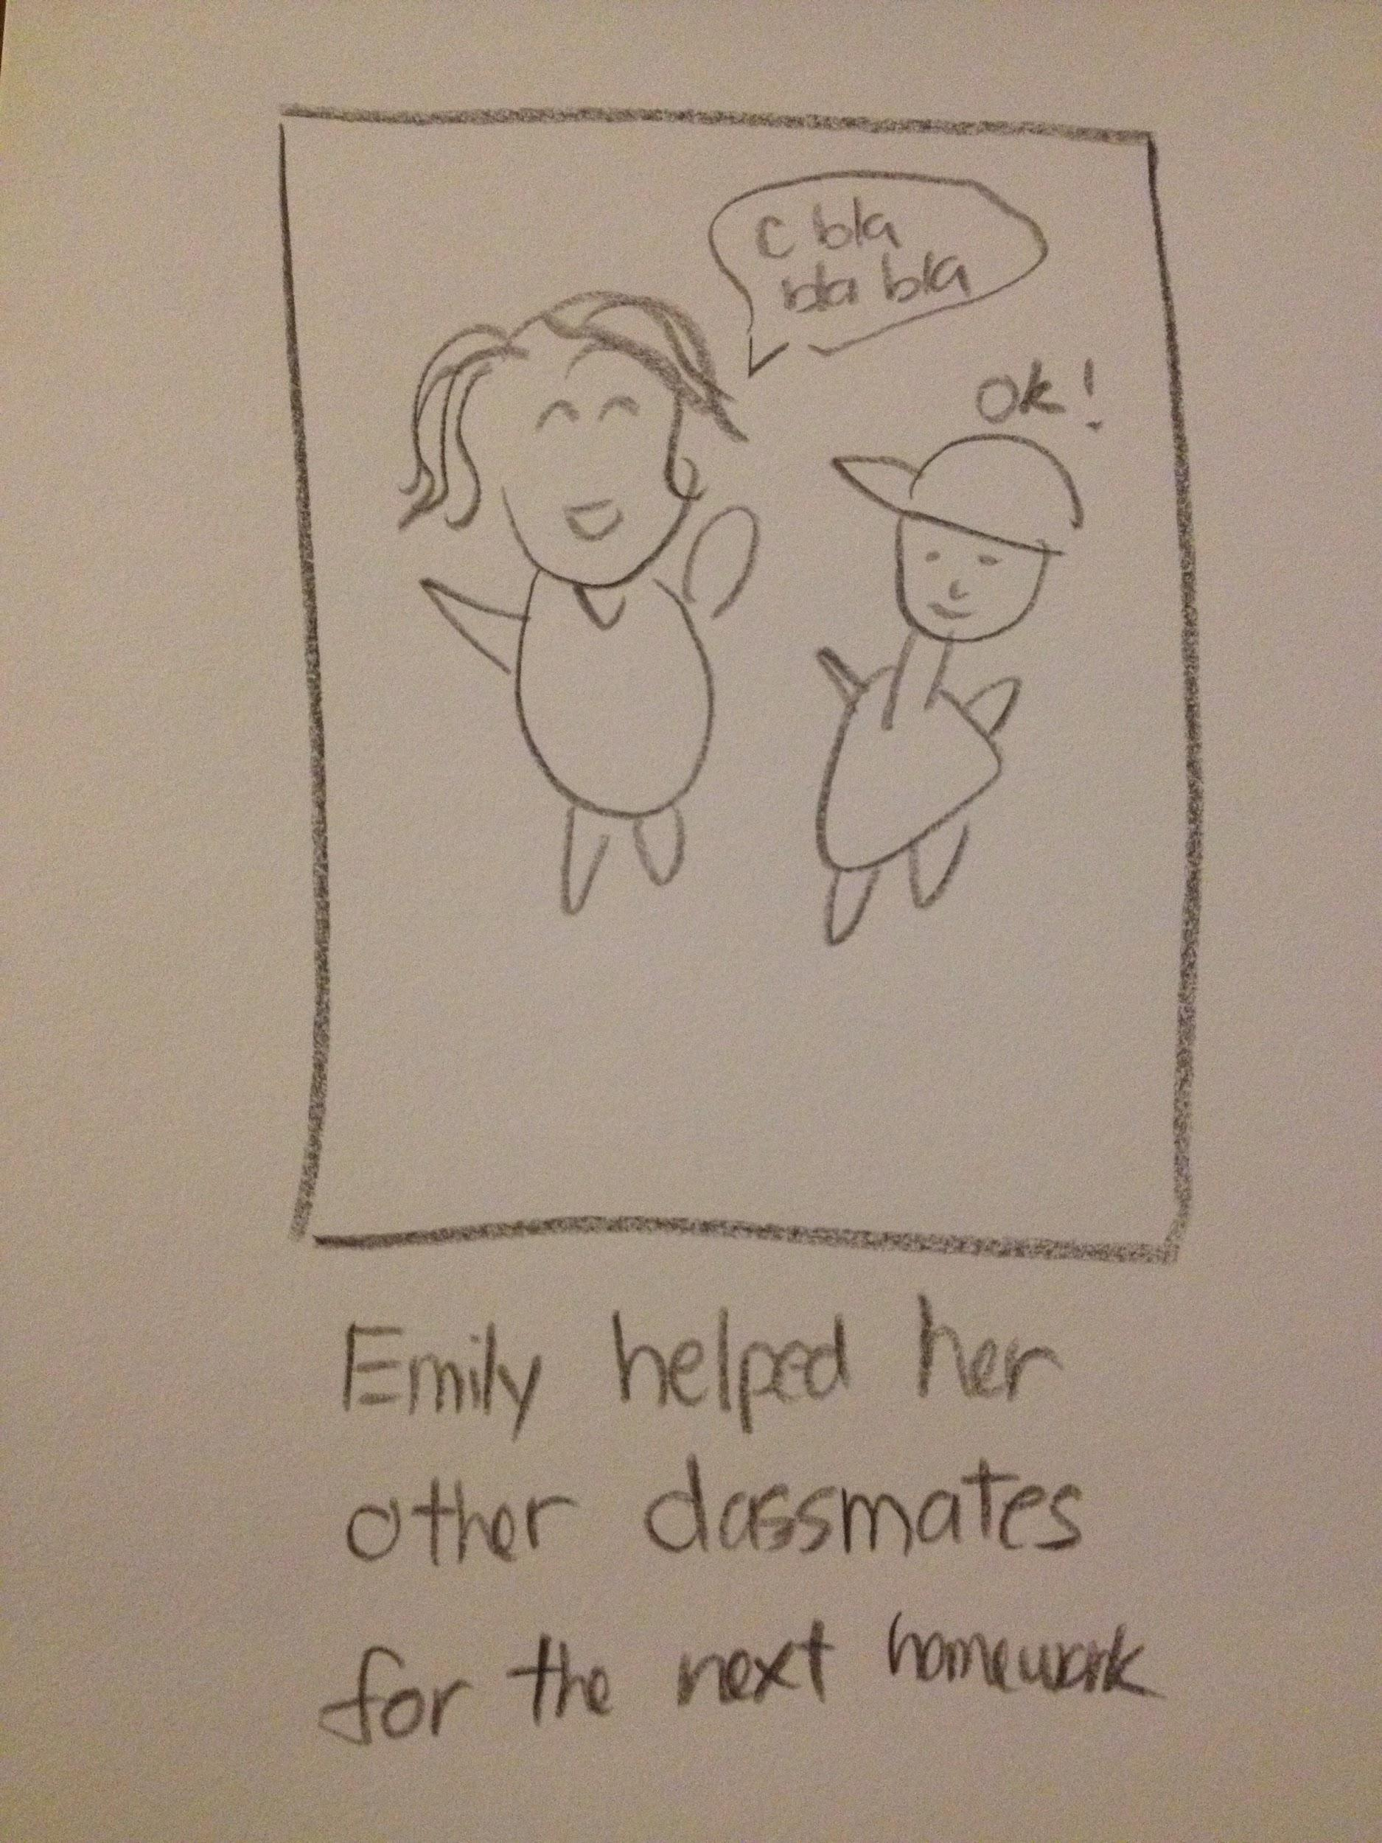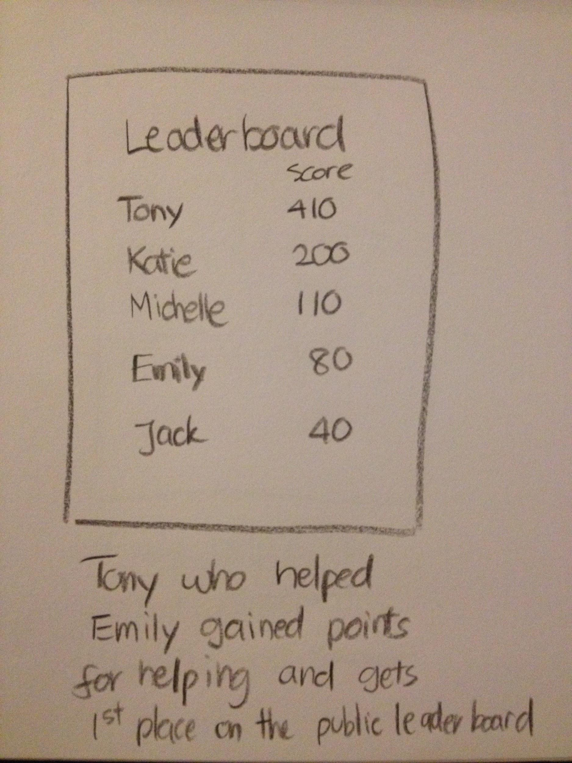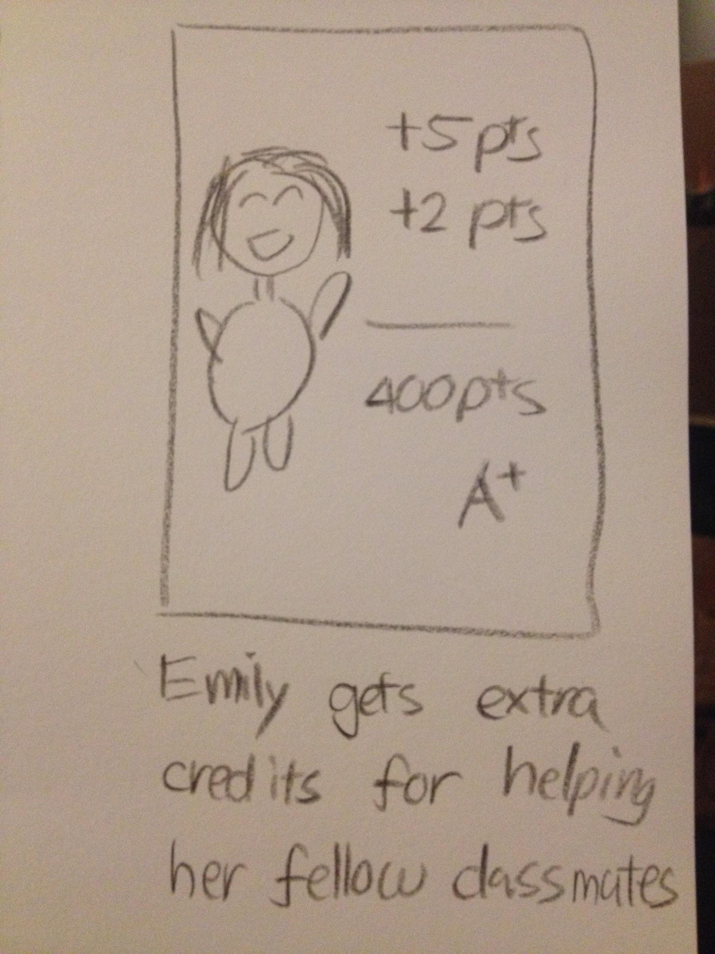

The storyboard is drawn with the persona Emily, who is social and likes to help her friends. It shows the game/reward system in class, which in the end, helped Emily finish her homework and at the same time get extra credit. This kind of system encourages peer-to-peer collaboration and would help students learn from each other. After all, peer learning is one of the most effective ways to learn because both parties will approach the same problem from different perspectives and peer collaboration helps both parties understand a difficult concept more fully.

**Storyboard Two (Paul : Games/ Reward System)**

The storyboard is drawn with the persona Paul, who is an introvert and loves to play video games. It shows the game/reward system in the new course, which in the end, motivated Paul to finish homework and gain rewards. This kind of system motivates students to work, and be rewarded in the end. This is one of the reasons why videogames are so successful, because humans love to be instantly rewarded after they have done the hard work. The system could also track your progress and compare it with your peers’ progress.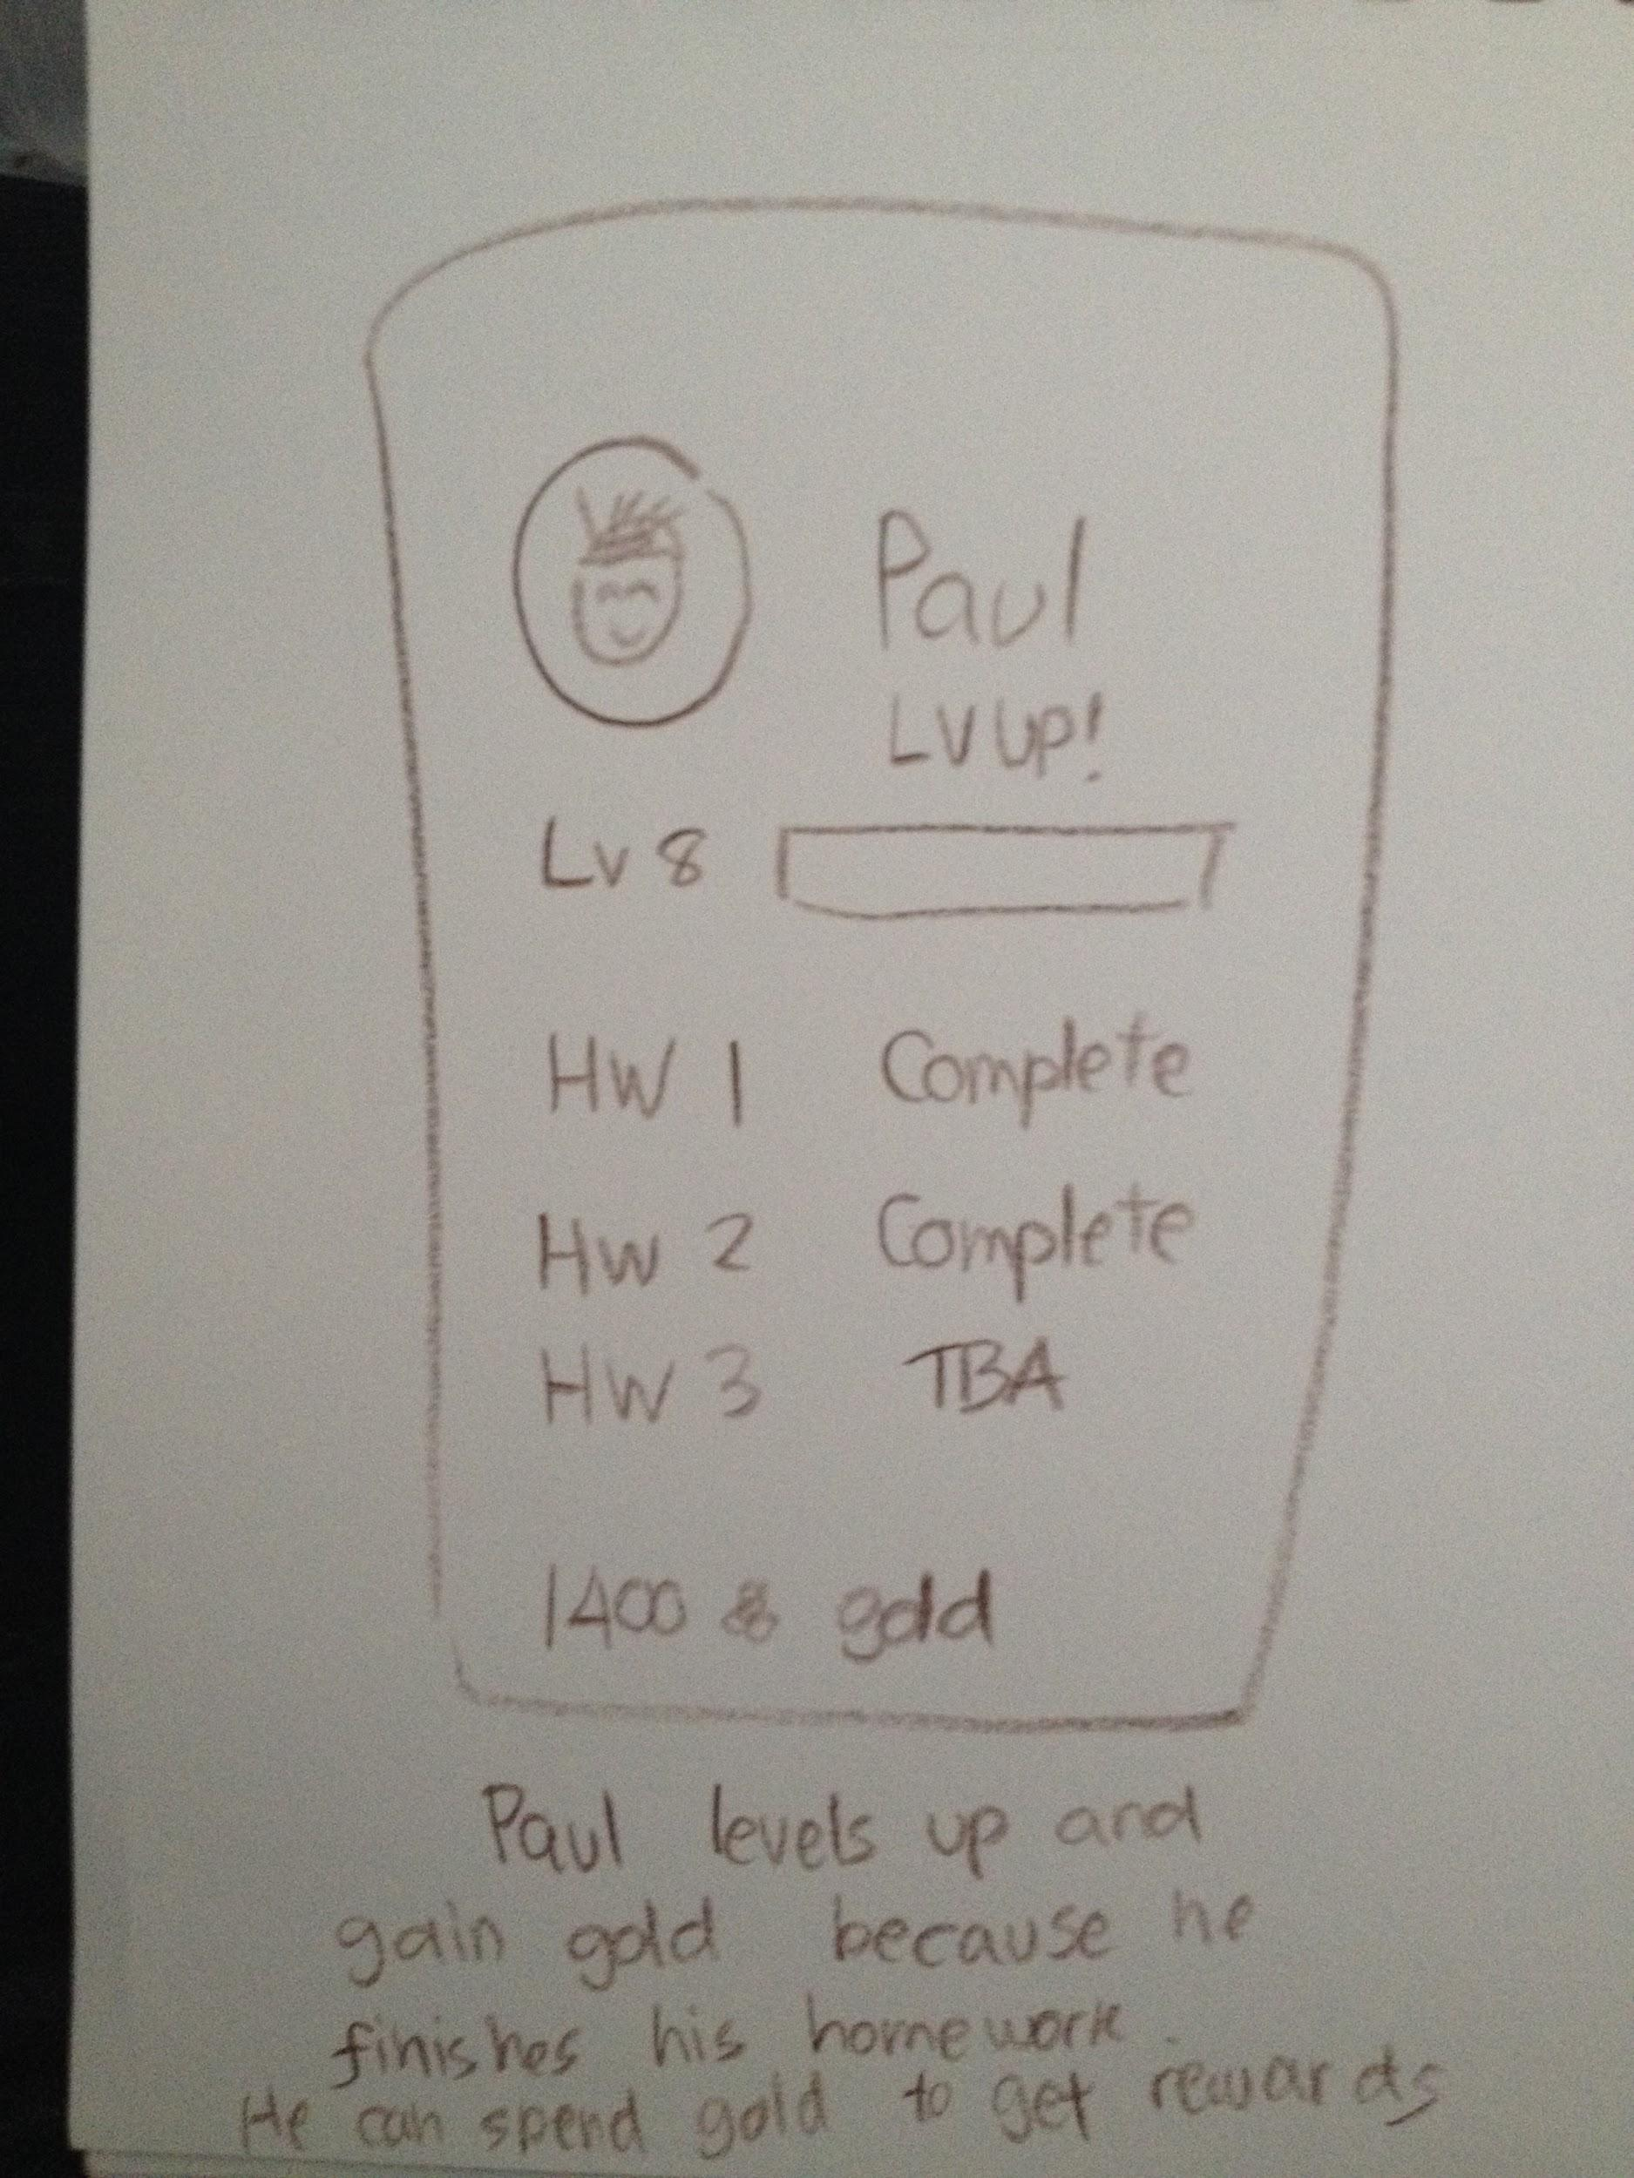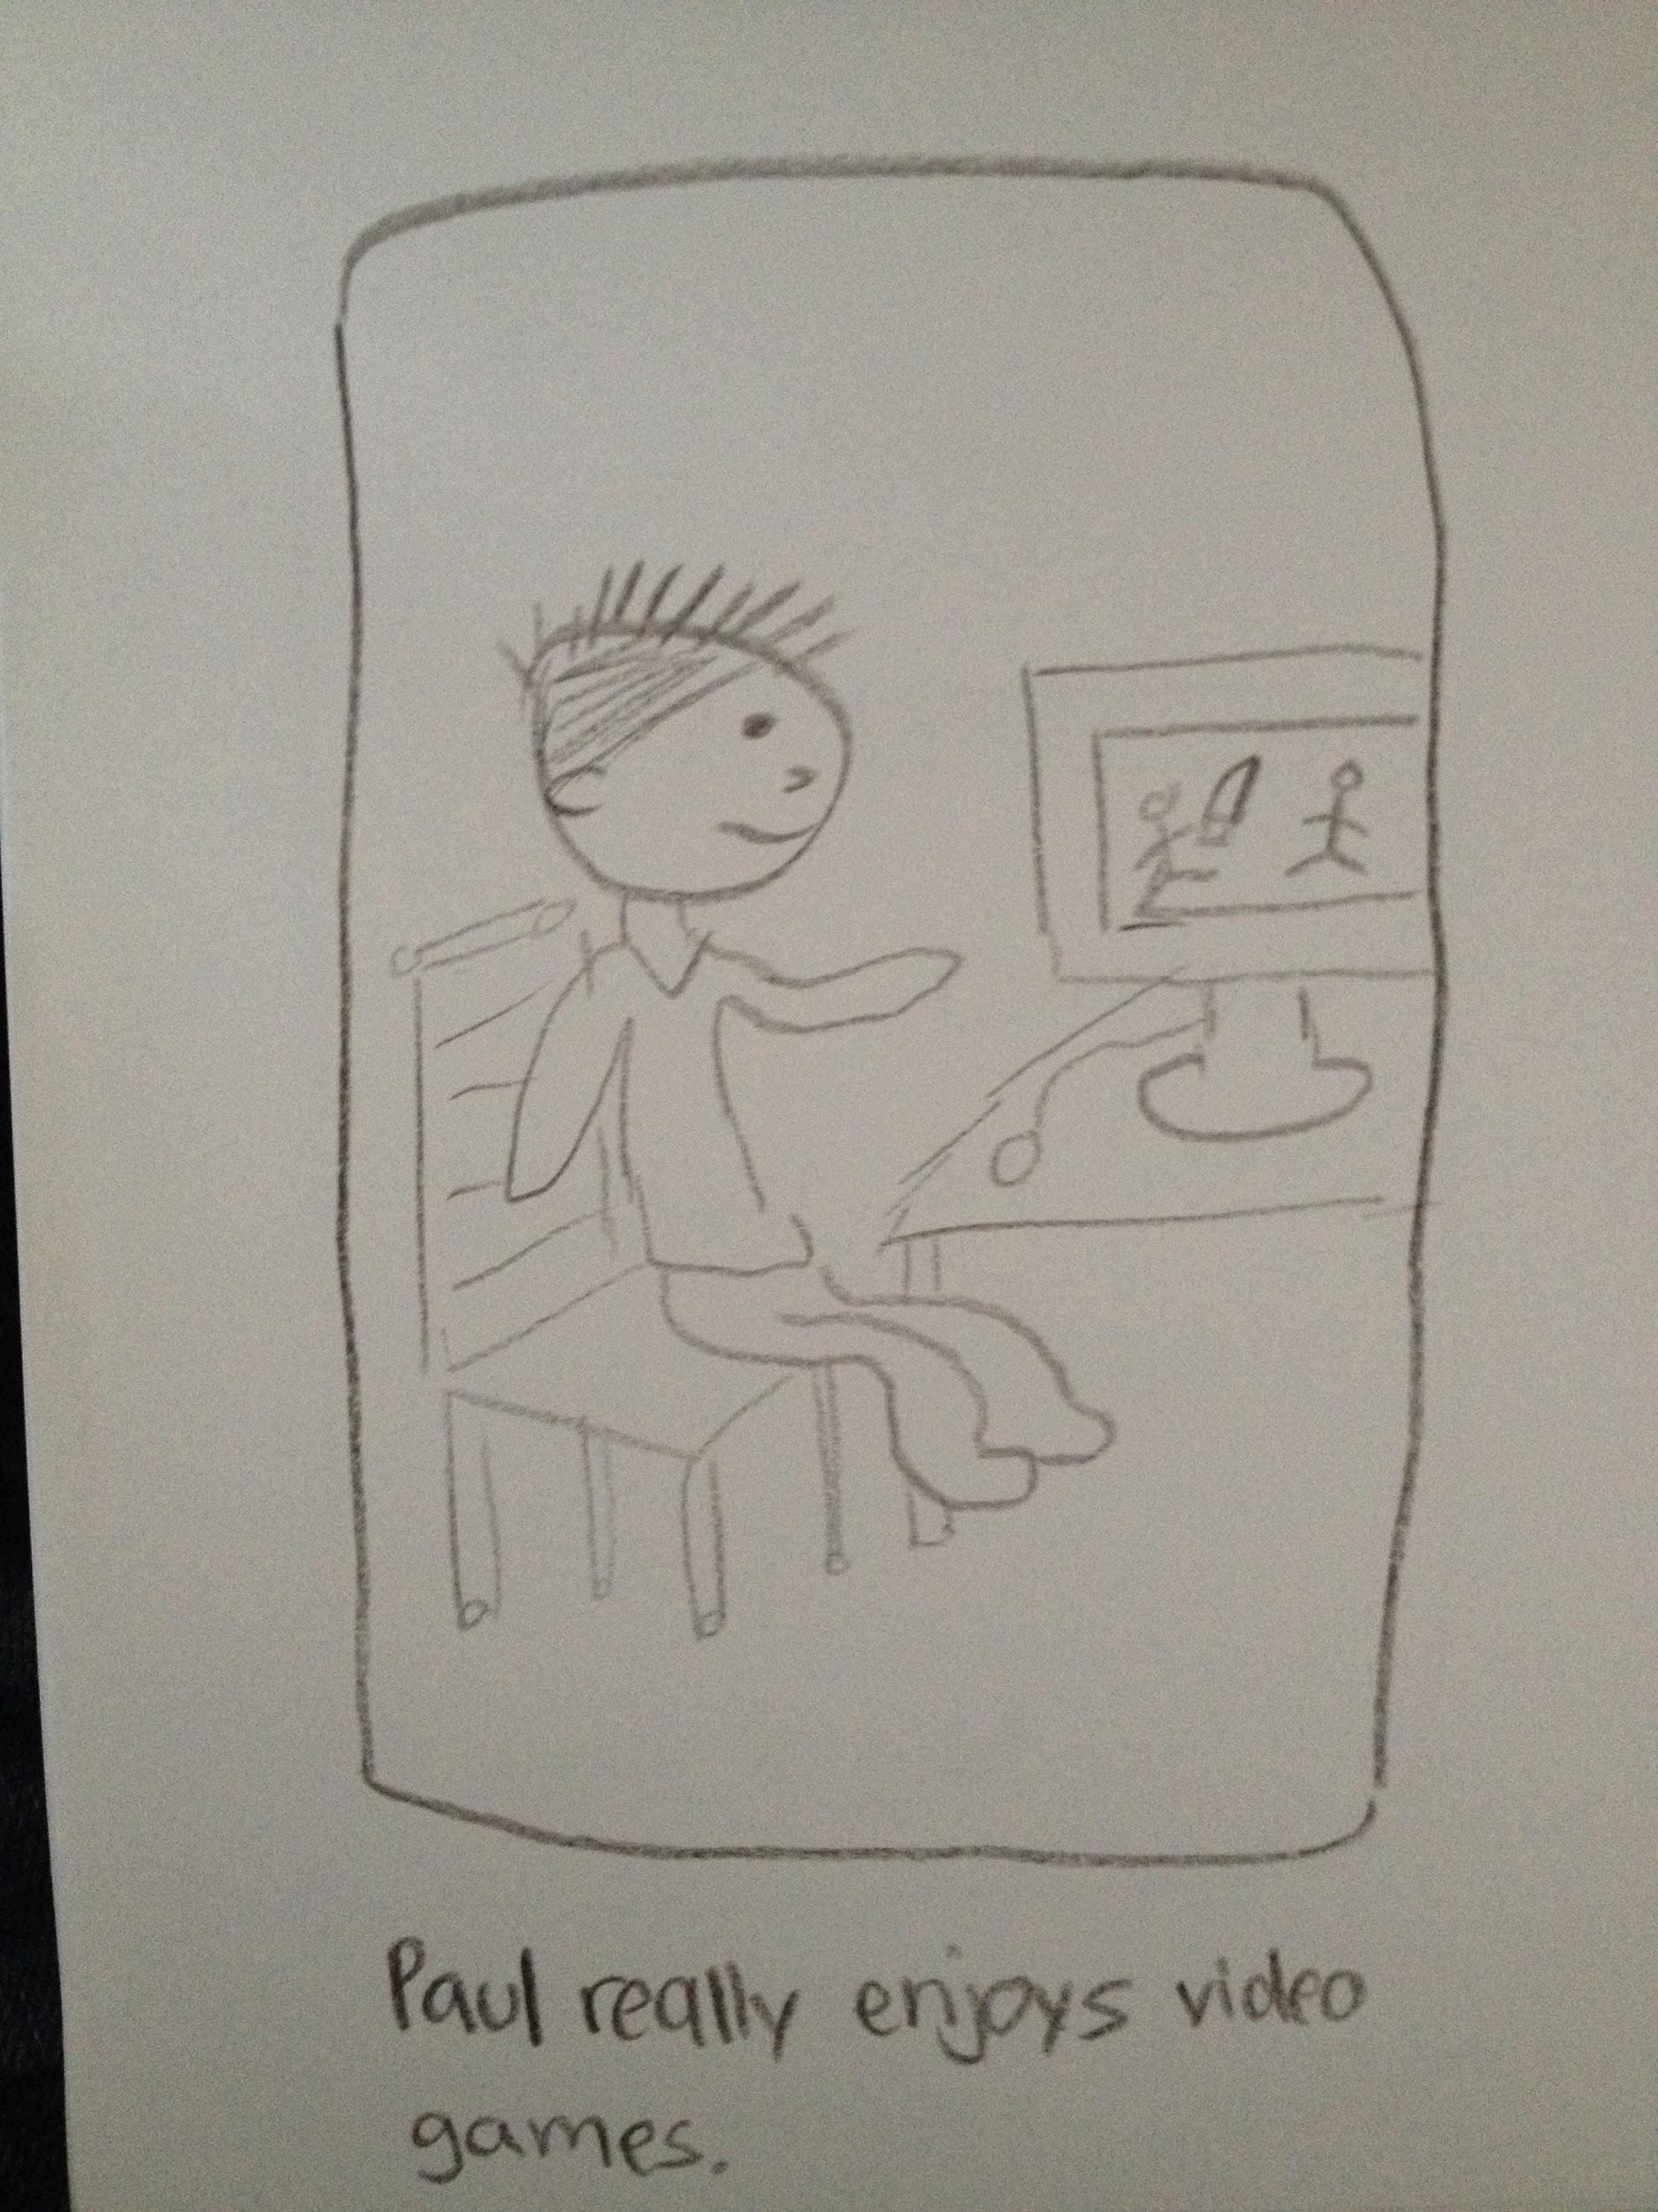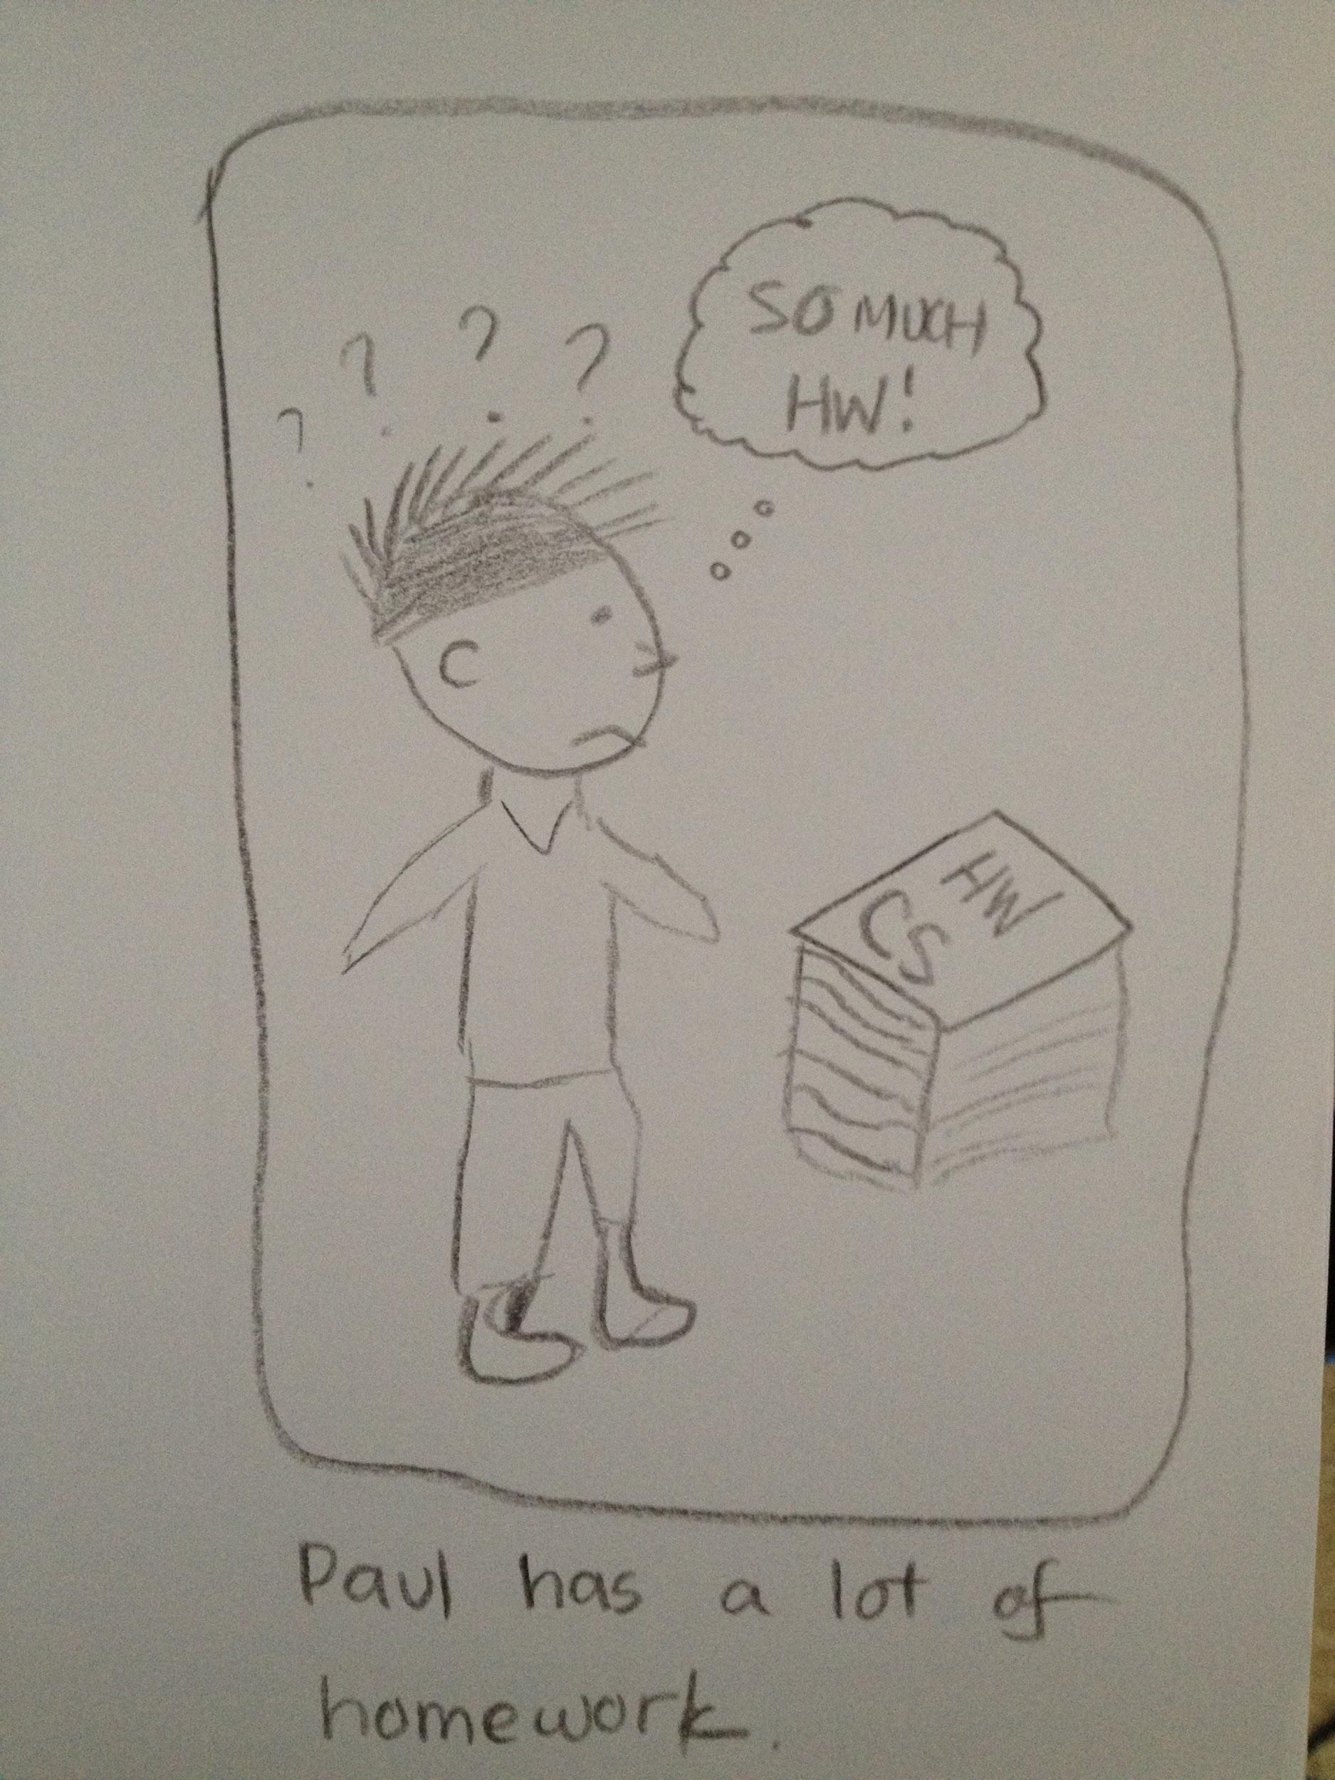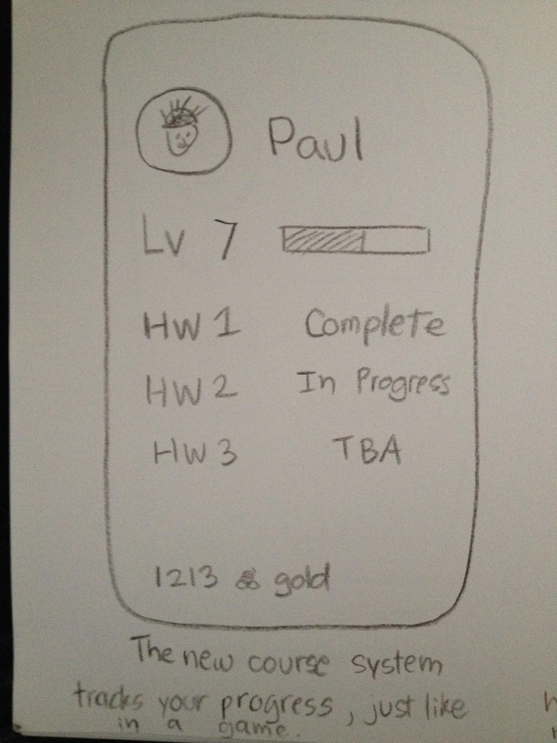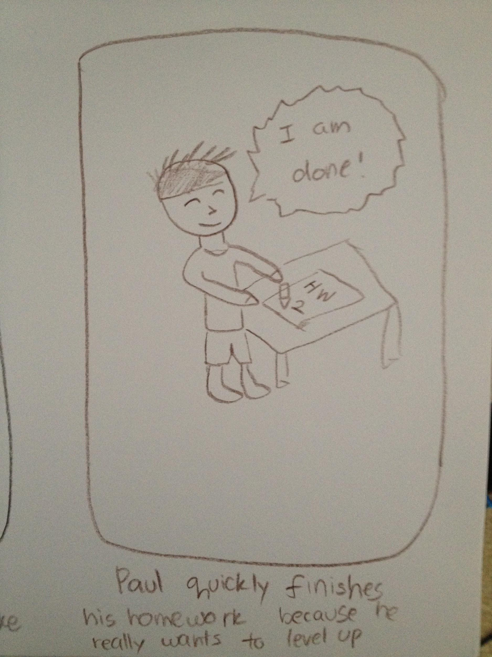

PART 2: Design Solution Choice

When approaching this project, we tried to produce a viable solution based on current technologies and that which could be produced within a realistic educational budget of a University. From our observations of the current higher education movement, we saw that class sizes were growing and moving into a large lecture hall setting. Due to the increasing size of lecture halls, we felt that the lack of student engagement is a prevalent issue that should be addressed in our design solutions. We assumed that with this movement, we needed to design a system that would work well within the constraints of a large lecture hall. We narrowed our results down to three possible solutions. The first solution we thought of was having LED screens strategically placed throughout the large lecture halls which would mimic those found at large sports/concert events. Our reasoning behind this approach was to have a more minimalistic style compared to our other two possible solutions. We felt that students sitting in the back did not feel as integrated with the class as they could be due to their distance from the professor. If we enlarged the image of the professor then perhaps the students would feel more included during class. For our second solution, we pulled inspiration from the increasing cultural shift to interact more through social media rather than in-person communications. The solution implements a software system that allows students to actively engage in the professor’s lecture by commenting, liking, and asking question in real time no matter how far from the professor they may sit. Lastly, we envisioned a software system that allows the class with the professor and fellow students in large lecture halls to play educational games together. These games would pull from current lecture material and challenge students to recall information quickly as well as develop new insights. It would increase interaction between students and the professor as well as students and other students.

In order to offer a design solution that would improve student engagement during class as well as a way to integrate fun into the classroom setting, we decided that it was best to combine two of our plausible design solutions together. We decided to incorporate an interactive learning system, with an augmented reality game. A good solution to the problem was one that could keep students engaged, while ironically distracting them from their distractions (electronics, friends, and seat locality), and overall enhance the learning process to make it as efficient as possible. Having an interactive system allows students to get help in real time regardless of their seating location, collaborate amongst the student body, comment on interesting topics, and help students develop deeper connections to lecture topics.. It achieves this by utilizing a software system that takes questions in real time, alerting the professor in real time by “flagging” him/her down to notify them about new questions, and has a gaming interface which acts as a complementary piece to the interactive learning system. The game mode would require a pair of augmented reality glasses, and the stadium style seating will be divided up into sectors that will represent different teams, each sector will receiving a series of different questions. The interactive system will then display four or five digital circles that each player in the sector can throw an augmented digital ball at and try to throw it into the circles. To score points, the majority of the sector has to: 1) make the digital ball into the circle, and 2) get the correct answer, each circle represents a possible answer choice. This requires all of the students to engage in teamwork, use dexterity which encourages students to be alert and engaged, and have fun! Together, these solutions offer a lot of fun, engagement, teamwork, constructive competition, and participation; the perfect recipe for learning!

We chose this combined solution as opposed to others because individually, the solutions would lack vital pieces to learning. As learned from field observations, students need the existence of tests and grade point averages to distinguish amongst one another, and provide for a sense of achievement as the institution of education is meritocracy. Observing this, an interactive system that does not create constructive competition will not create enough motivation for students to become engaged (a problem that currently exists with Piazza, among other student information systems). Also from observations and personal experience, learning is much easier when one has a positive attitude about the subject; having fun is a great way to increase an individual’s mood and attitude which will make learning memorable and efficient. Games pick up the slack that interactive systems lack, but games alone would not create the serious support structure that is needed, and do not create an avenue for professors to engage with students, which is vital. Thus, together, the two systems offer an efficient solution that helps solve the problem of lack of student engagement in the current education system.